**WORK IN PROGRESS**

Team Members:

Aavash Chand

Shreya Singh

Sujit Gyawali

Sushant Neupane

Sushrut Rimal

Yunik Pandey

# **TABLE OF CONTENTS**

**TABLE OF CONTENTS 2**

**COMMUNICATION TOOLS USED 3**

Jira 3

Discord 3

Physical Meeting 4

GitHub 4

**1. INITIATION PHASE 5**

1.1 Project Charter 5

1.2 Meeting Agenda 7

**2. PLANNING PHASE 9**

2.1 Belbin’s Analysis 9

2.2 Skill Audit 9

2.3 MS Project 14

**3. EXECUTION PHASE 16**

3.1 Entity Relationship Diagram 16

3.2 Use Case Diagram 19

3.3 Requirement Catalogue 21

3.3 Logo 24

3.4 Wireframe 25

**4. WEBSITE DEVELOPMENT 30**

# **COMMUNICATION TOOLS USED**

## Jira

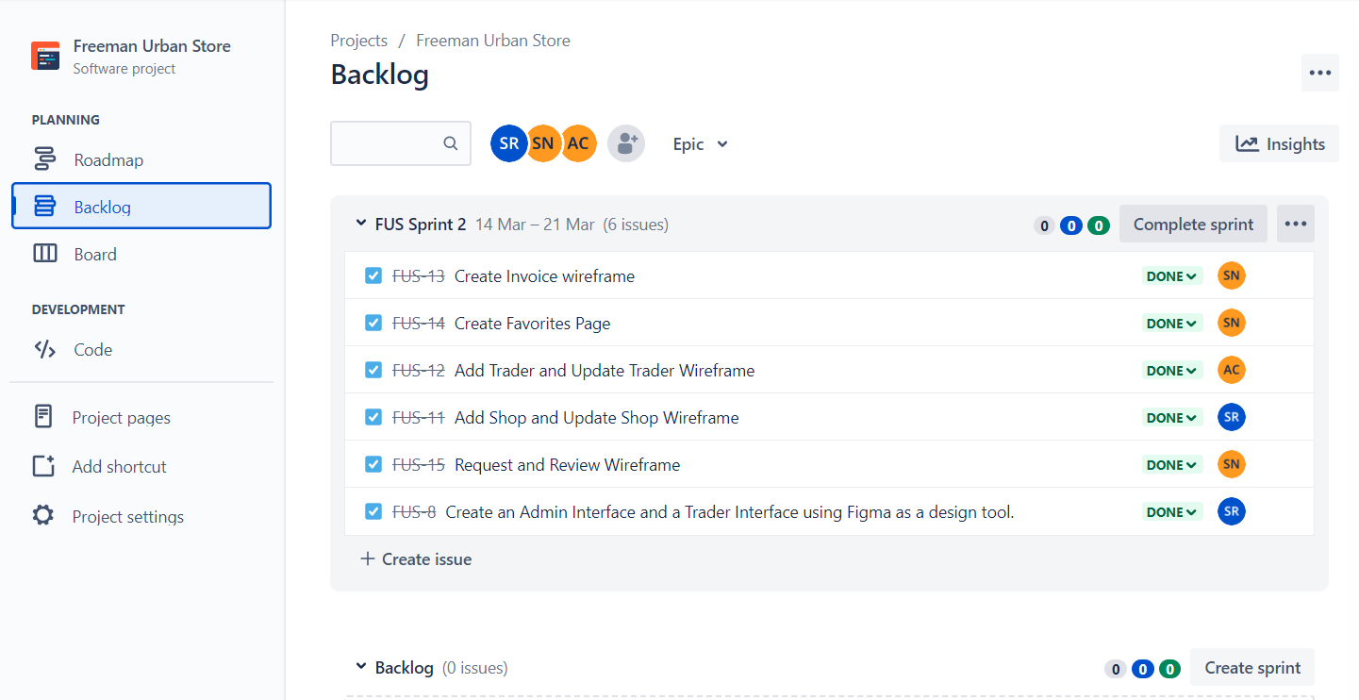

LINK <https://freemansurbanstore.atlassian.net/jira/software/projects/FUS/boards/2>

## Discord

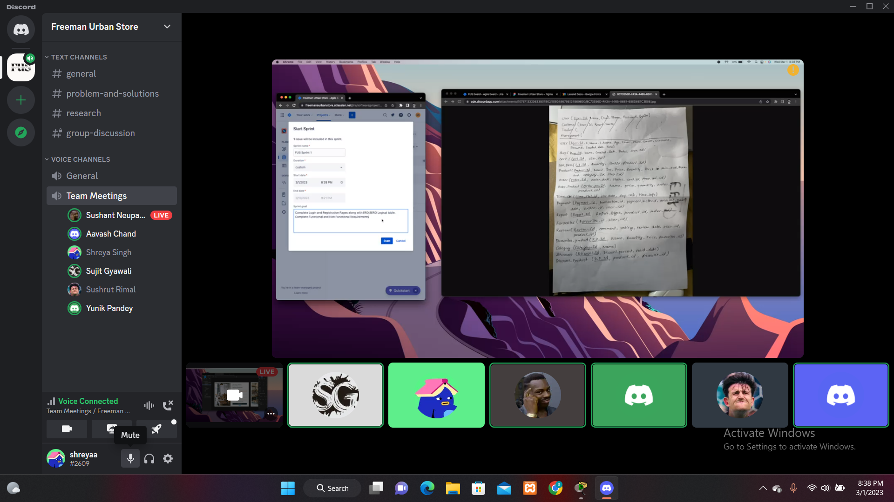

LINK https://discord.gg/YxpMUH8r

## Physical Meeting

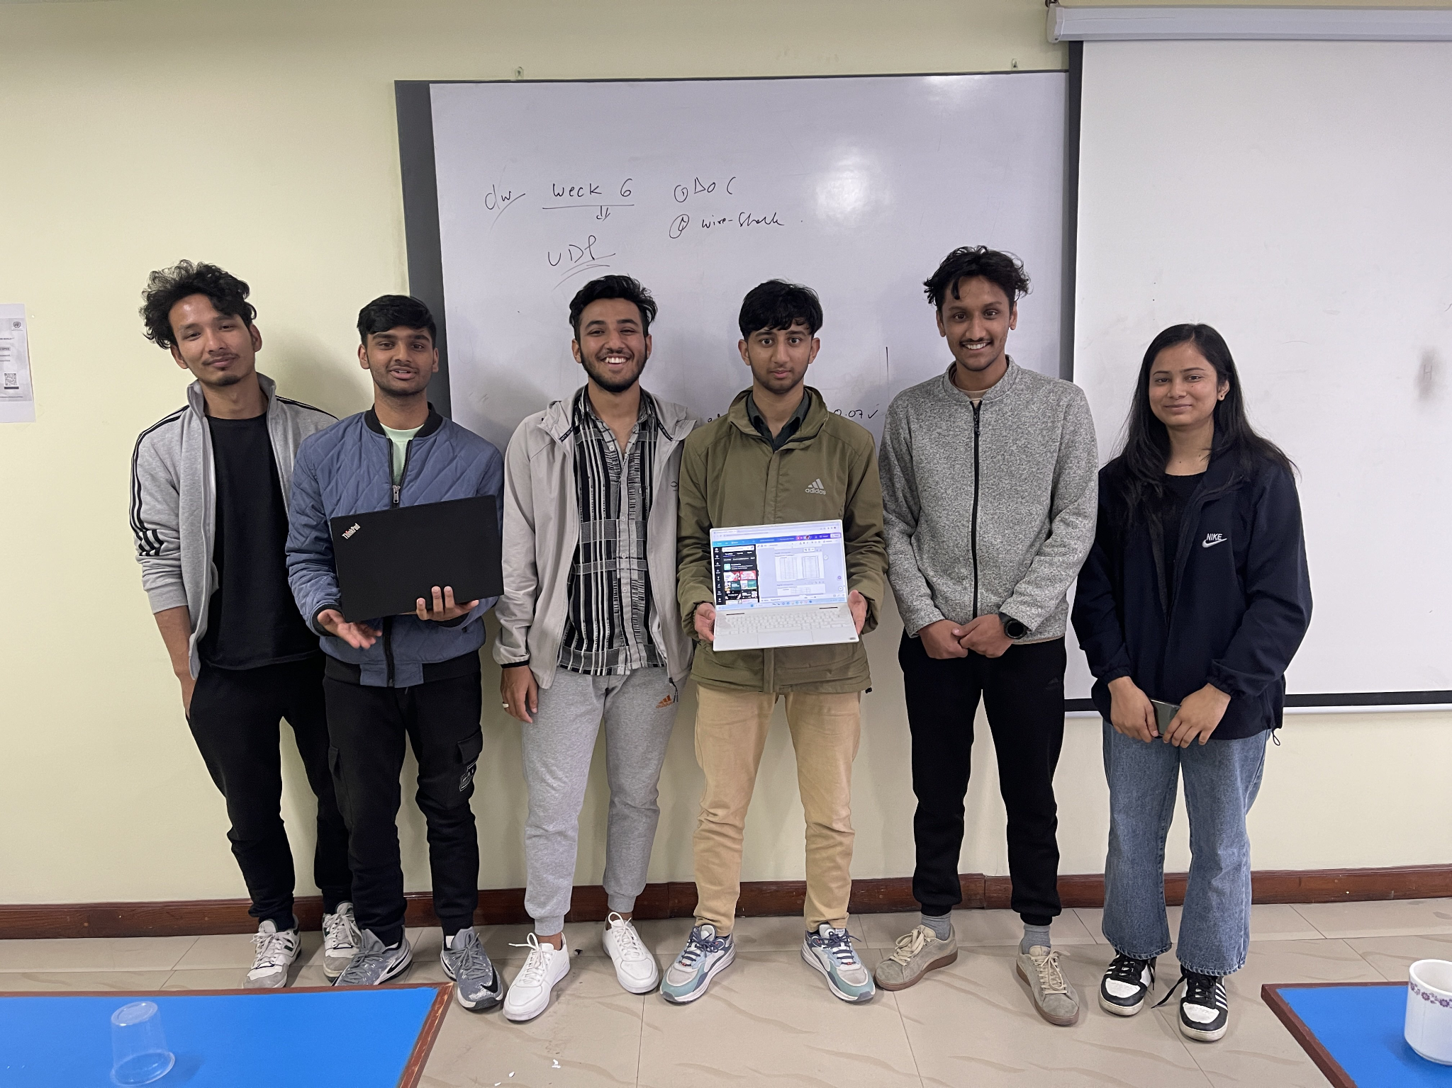

## GitHub

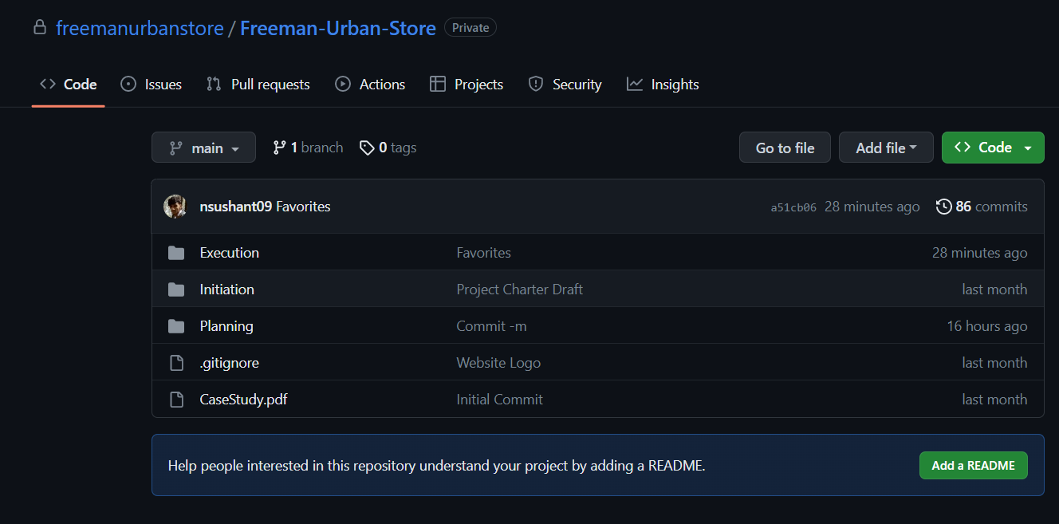

LINK https://github.com/freemanurbanstore/Freeman-Urban-Store

# **INITIATION PHASE**

## 1.1 Project Charter

**Project Title:** Freeman Urban Store

**Project Manager:** Rohit Pandey

**Project Sponsor:** Leeds Beckett University, The British College

**Date Prepared:** 02/15/2023

**Finish Date:** 05/01/2023

**Version Control**

| **Version** | **Date** | **Summary of changes** |
| --- | --- | --- |
| 1.0 | 20/02/2023 | Initial version. |
| 1.1 | 25/02/2023 | Updated Project Justification and Project Scope. |

**Project Justification**

The aim is to develop a web-based E-commerce system to order fresh goods online from local independent shops, which will be easier for customers of that areas. The group of small independent traders are controlling the whole sector till date, but recently national chains have identified the need to adapt to changing customer needs and behaviours. Locals of that area who are willing to support small independent business but are not able to be manage time during regular business hours are the intended end-users.

The main reason for starting this project is to go along with the changing customer needs and behaviours. By offering an e-commerce platform, we hope to capture a larger share of the market and remain competitive. The order for any product can be placed only after the registration within the website. Adding a product to the cart in only possible after you are logged in through your credentials. Product is showcased in website along with their description of all the required things like calories, daily intake, proteins, etc. Searching of a specific product is easier with the presence of search bar and also ranging from different criteria. Also sorting through product name and product rate is also possible which make the website more convenient to use. Also, collecting of the orders are only possible three days a week with different time slots whereas the payment system of PayPal is only accepted. For the proper improvisation of the product quality there is a specific section for customers in order to rate and review the product. After implementing all these we expect these benefits: increased sales and revenue for the traders, improved convenience for customers, and the ability to compete with national chains that have recently entered the area.

From the viewpoint of the customer, this e-commerce platform allows them to order fresh products from local independent stores. Consumers will have the option of browsing the website by store or product category. On the other hand, the traders can maintain their local character as independent stores where they operate while still offering a different way to buy for food and other goods.

**Project Scope**

**Customer Interface**

1. Easy product search and navigation.

2. Mobile and desktop compatibility with popular browsers.

3. Ability to purchase from multiple traders and pay at once, with tracking by trader.

4. Customer required to sign in before ordering.

5. Collection point at one of the shops with three collection slots.

6. Payment options such as PayPal for easy transactions.

**Trader Interface**

1. Platform to manage products and shop information.

2. Starting with five initial traders with expandability up to ten traders.

3. Detailed product information for effective inventory management i.e., Inventory Management System.

4. Unique product categories for each trader.

5. Credentials and interface for individual trader account.

**Management Interface**

1. Dashboard for managing customer and trader account.

2. Inspecting every trader for proper quality control of the product they are selling.

3. All the payment information of trader can be accessed by admin.

4. Activity of every logged in user can be tracked by admin.

5. Product proper statistical report based on periodic reports.

**Duration**

Initiation: 20/02/2023 – 27/02/2023 [1 week]

Planning: 28/02/2023 – 11/03/2023 [1 ½ weeks]

Execution: 12/03/2023 – 25/02/2023 [2 weeks]

**Estimated Budget**

Format: Hours per day * Days per week

Sujit Gyawali: 4 * 5 = 20 hours

Yunik Pandey: 3 * 6 = 18 hours

Shreya Singh: 2.5 * 6 = 15 hours

Sushant Neupane: 4 * 5 = 20 hours

Sushrut Rimal: 3.5 * 6 = 21 hours

Aavash Chand: 2 * 5 = 10 hours

Total Hours per week = 104 hours

Hence total hours for 12 weeks = 104 * 12 = 1248 hours

## 

## 1.2 Meeting Agenda

**WEEK-1:**

The entire team agreed to convene a meeting to strategize the initiation of the project. Within this gathering, project names were suggested and we ultimately settled on one, followed by a discussion about the project logo. By the end of the week, we had finalized the logo.

**WEEK-2:**

At the start of the week, the team discussed the project charter. This involved documenting the project's objectives and rationale. The team also briefly discussed the requirements for the customer, trader, and management interface, as well as estimated timeframes for each phase. In addition, the budget for the project, which was calculated in hours, was determined.

**WEEK-3:**

At the start of the week, the team came together to finalize and document the project charter. This was completed and prepared for submission. On Wednesday, the team discussed the tasks for the following week and scheduled a meeting in one of the classes after our respective lecture. Before the weekend, the team created a contract that included the team structure, procedures, rules, and consequences for breaching the contract. All team members were present during the creation of this document.

**WEEK-4:**

The team gathered together on Sunday to finalize the team contract, which was then reviewed by the project manager. After this, every team member signed the contract. In the subsequent days, each team member conducted a skill audit, discussing the applications, languages, and skills required for the project's successful completion. They rated their knowledge of each skill on a scale of 1 to 5 and created plans for objective and training actions to improve their understanding of any less familiar skills.

**WEEK-5:**

During our meetings this week, we commenced planning for the Entity Relationship Diagram (ERD) and Enhanced Entity Relationship Diagram (EERD) and began working on the assigned task. Additionally, we collaborated to plan and complete the wireframe. Along with the wireframe, we also finished the ERD, EERD, decomposite, composite, and website logo, which were all documented and prepared for review and final submission.

**WEEK-6:**

The primary agenda for this week's meeting was the Usecase diagram. Half of the team was assigned to work on the Usecase diagram while the other half focused on identifying and documenting the functional and non-functional requirements of the project. During the designated meeting hours, the team gathered in the innovation room of our college library to collaborate and work together on the Usecase diagram.

**WEEK-7:**

During our meetings this week, we dedicated our time to planning and completing the MS Project, which included creating a Gantt chart, resource sheet, timeline, and calendar. In addition, we also worked on preparing for the upcoming progress presentation. We created slides, finalized documentation, and rehearsed our presentation to ensure we were well-prepared to deliver it. All of these deliverables have been completed and are now ready for submission.

# **PLANNING PHASE**

## 2.1 Belbin’s Analysis

**TEAM BELBIN’S ANALYSIS**

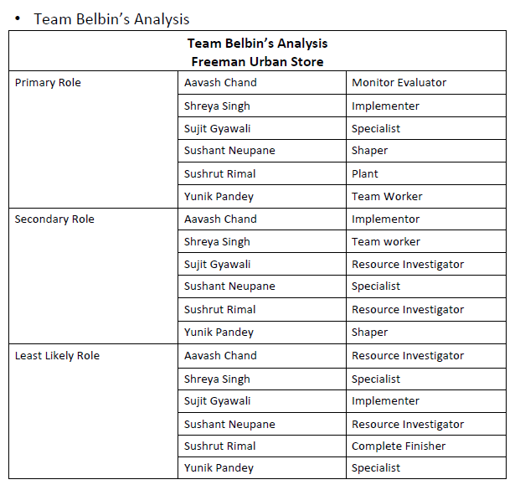

## 2.2 Skill Audit

**TEAM SKILL AUDIT**

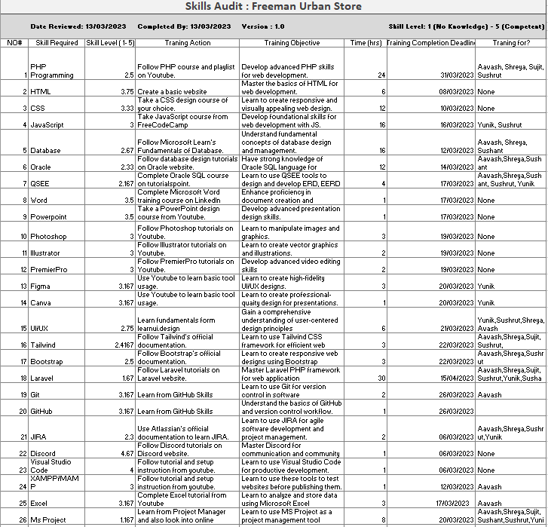

**INDIVIDUAL SKILL AUDIT**

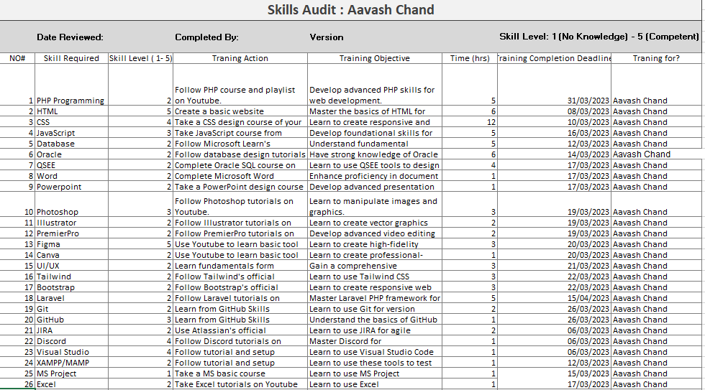

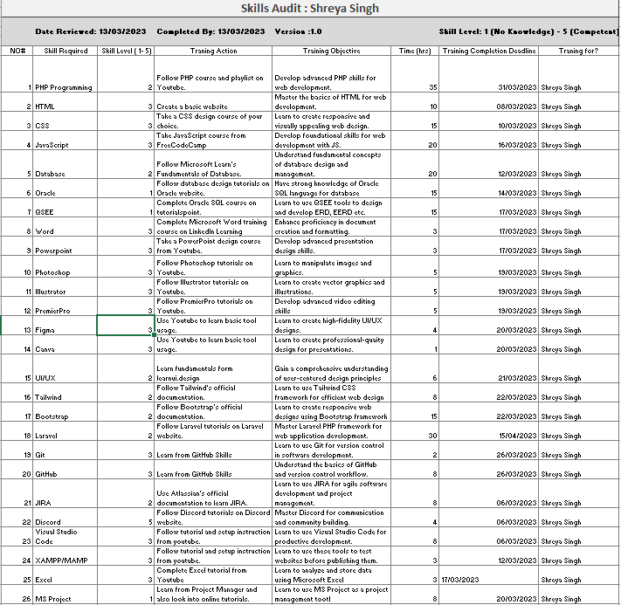

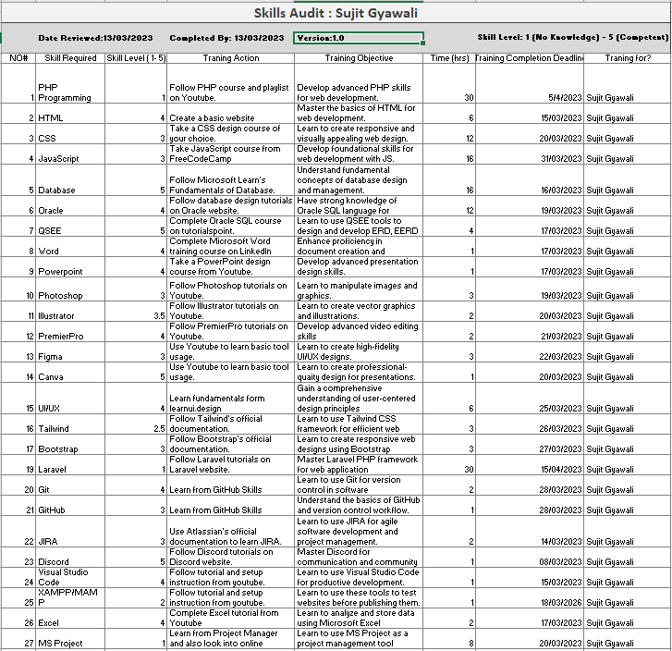

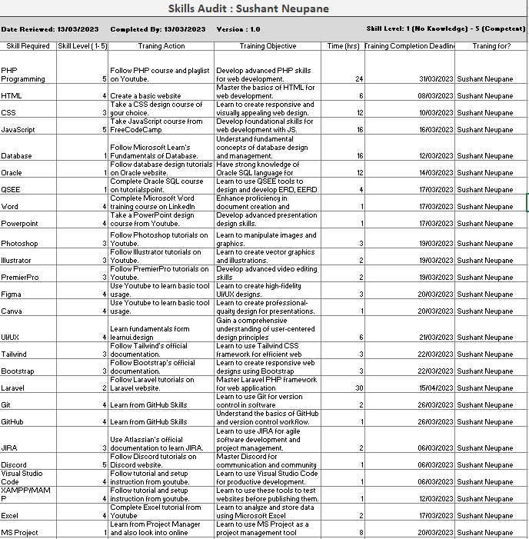

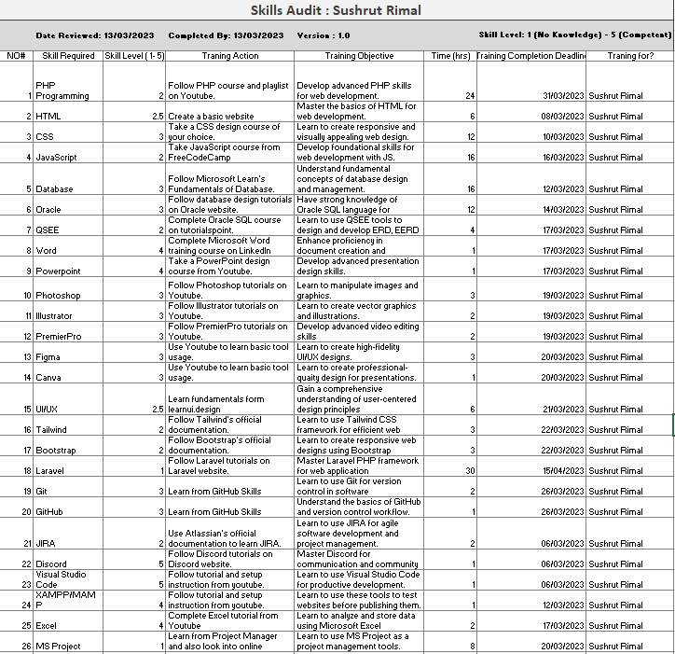

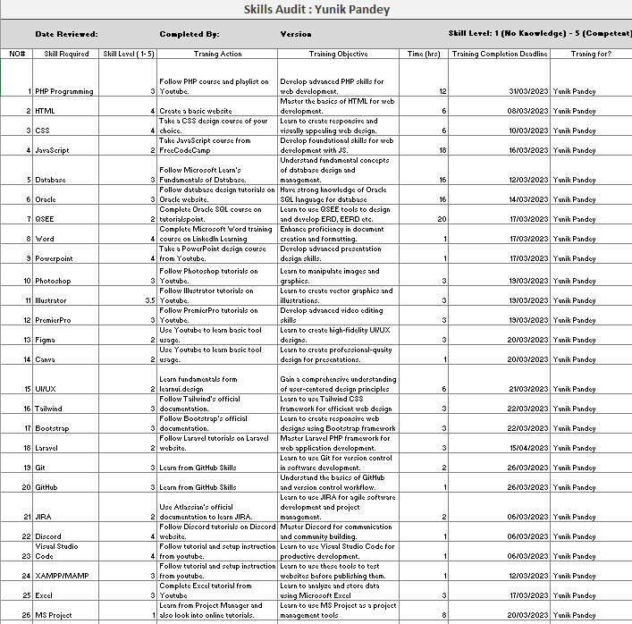

## 2.3 MS Project

**GANTT CHART**

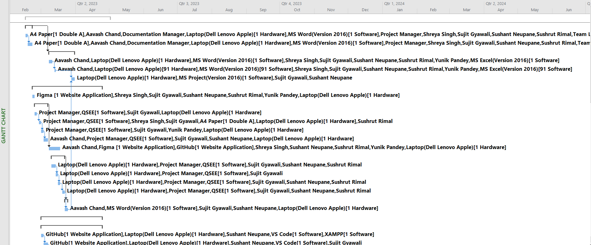

**TASK SHEET**

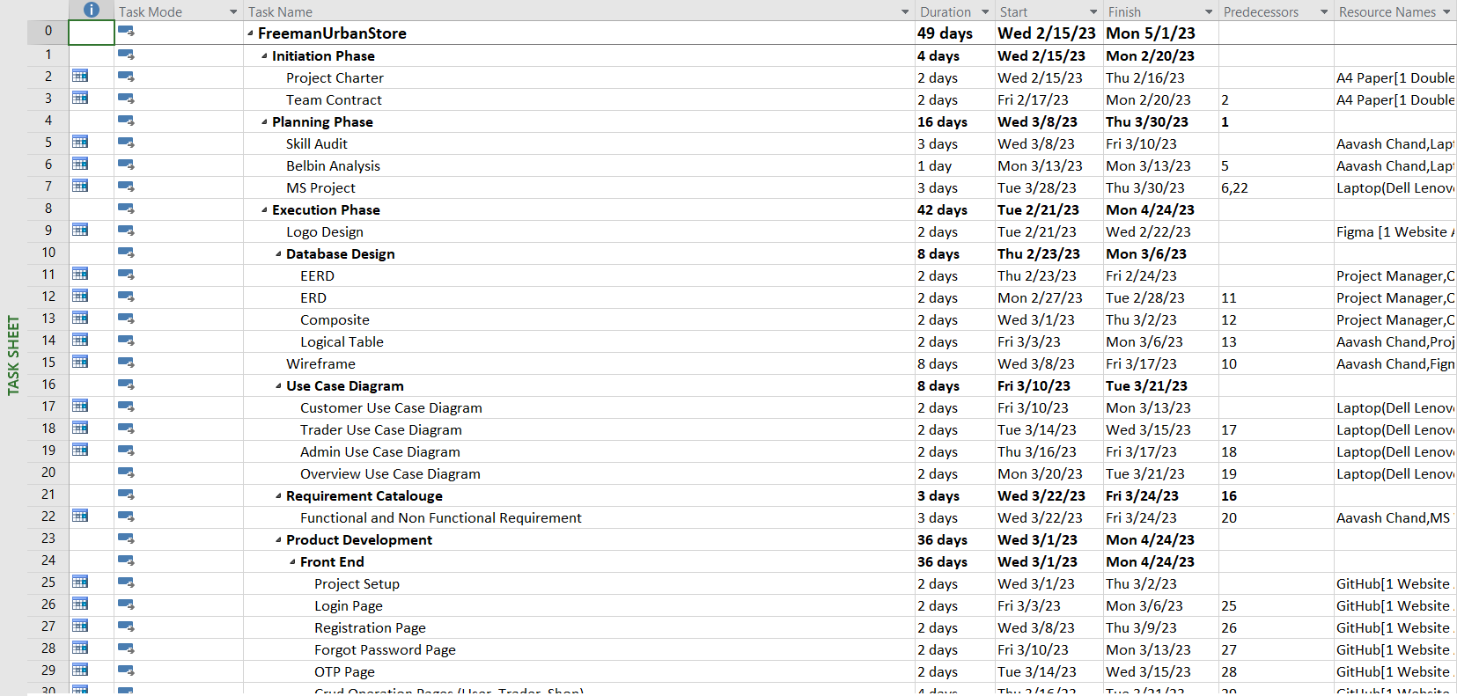

**TIMELINE**

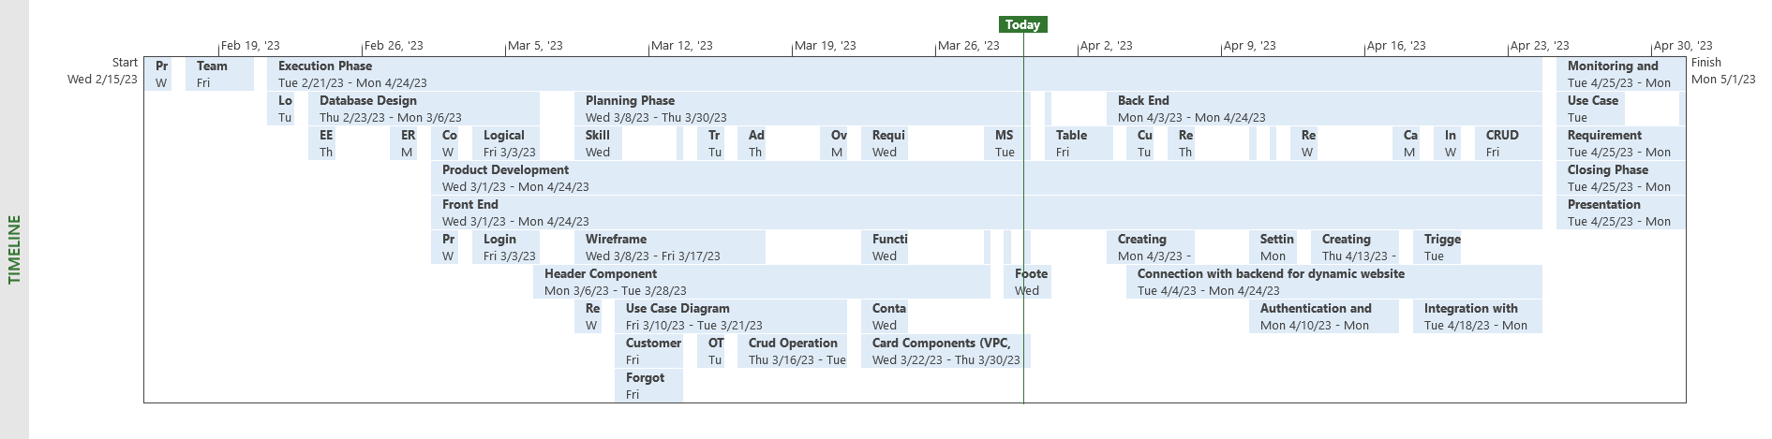

**CALENDAR**

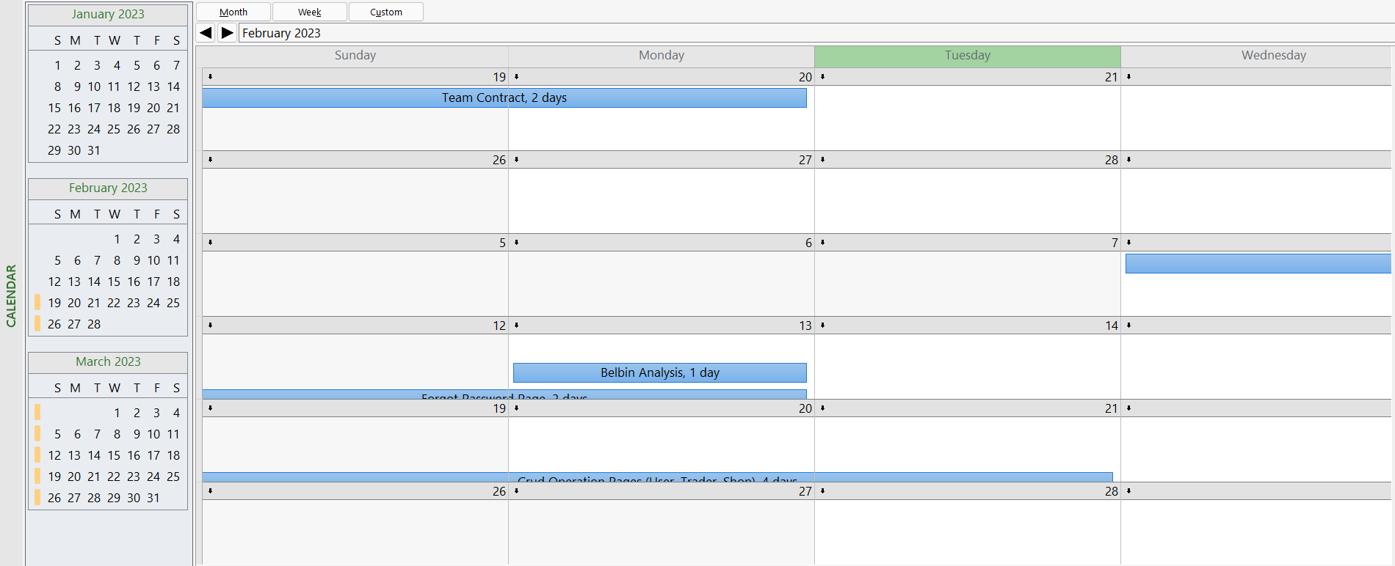

**RESOURCE SHEET**

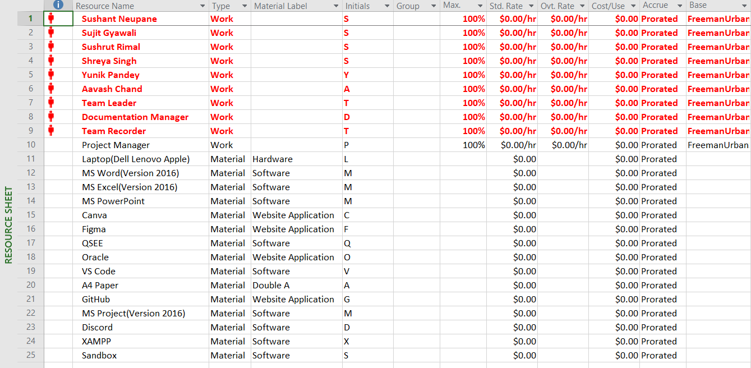

**HOLIDAYS**

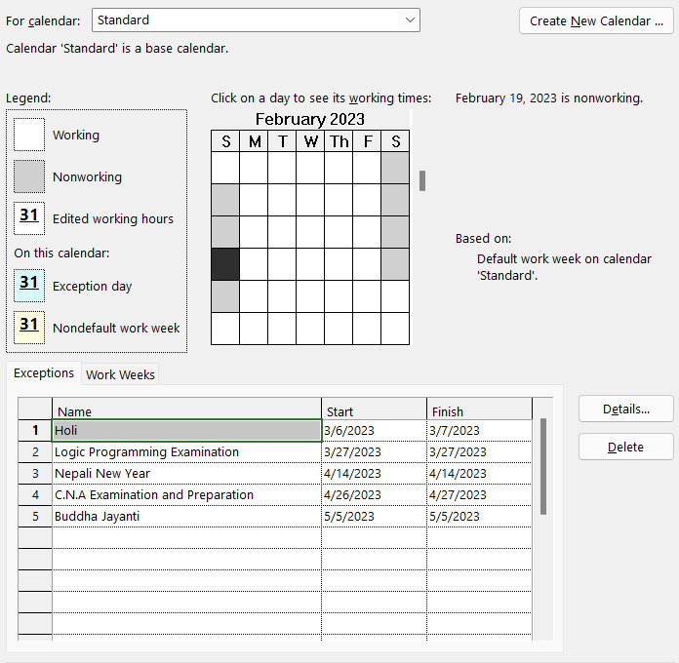

# **EXECUTION PHASE**

## 3.1 Entity Relationship Diagram

**EXTENDED RELATIONSHIP DIAGRAM**

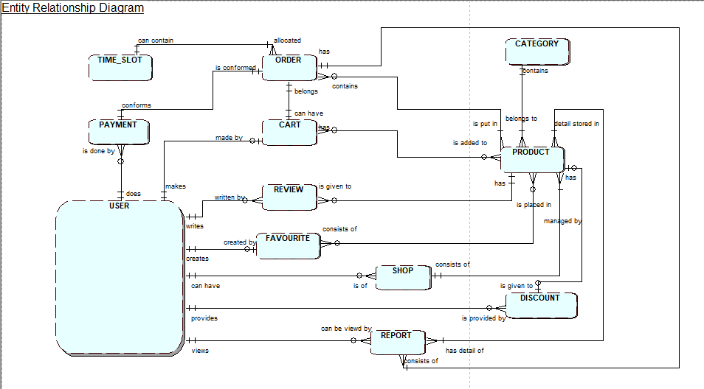

**EXTENDED ENTITY RELATIONSHIP DIAGRAM**

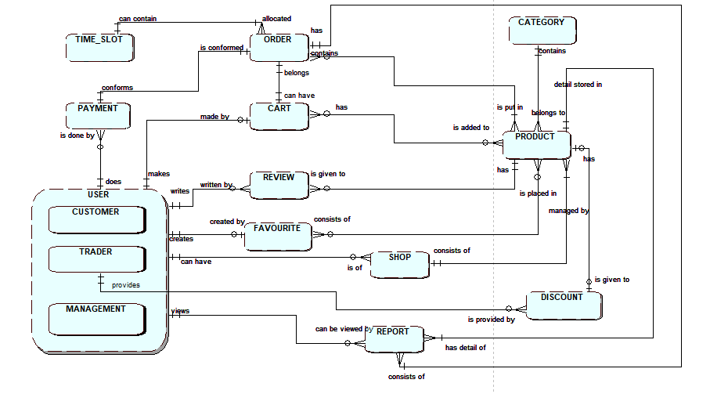

**FINAL COMPOSITION DIAGRAM**

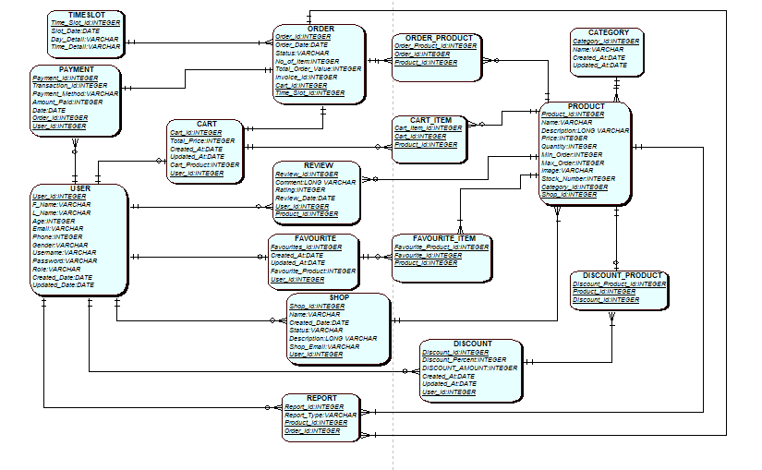

**LOGICAL TABLE**

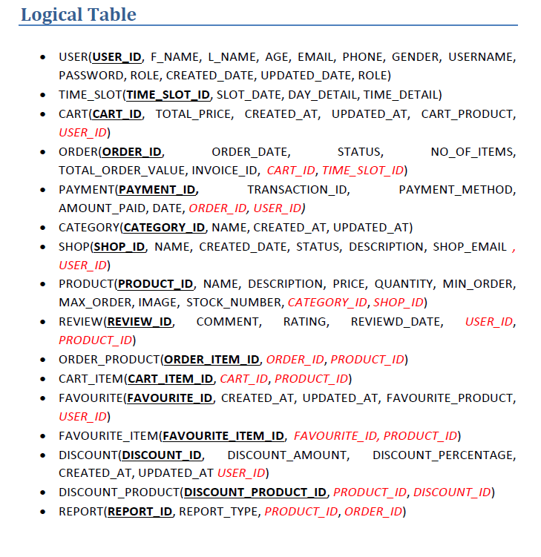

## 3.2 Use Case Diagram

**OVERVIEW USE CASE DIAGRAM**

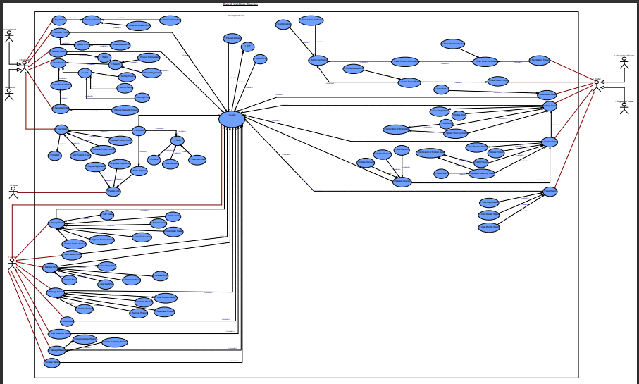

**CUSTOMER USE CASE DIAGRAM**

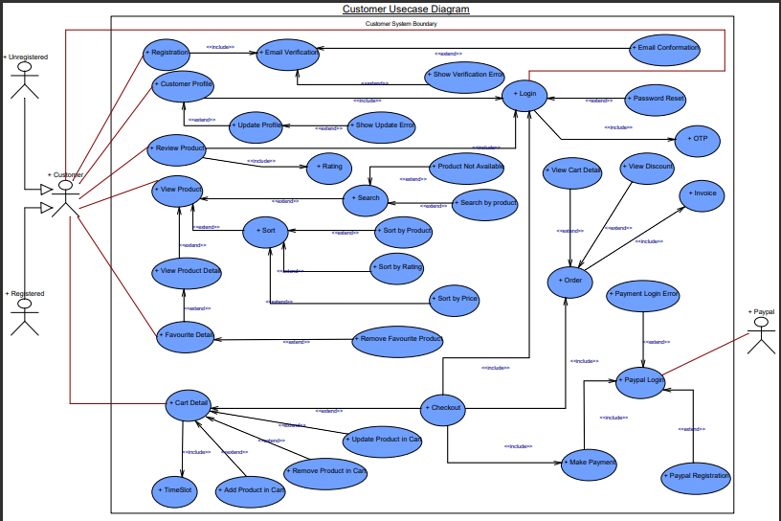

**TRADER USE CASE DIAGRAM**

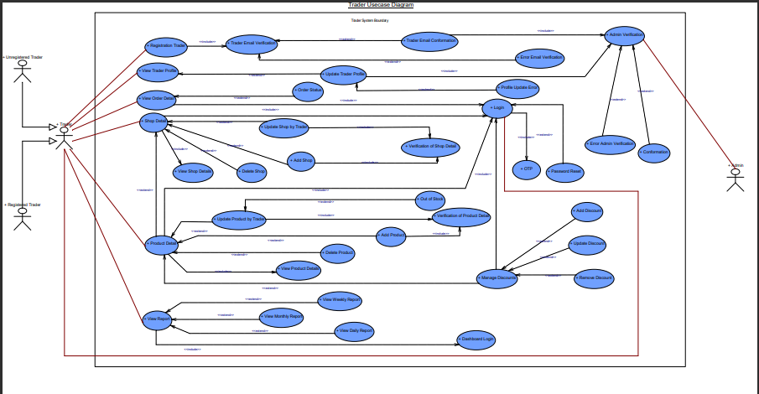

**ADMIN USE CASE DIAGRAM**

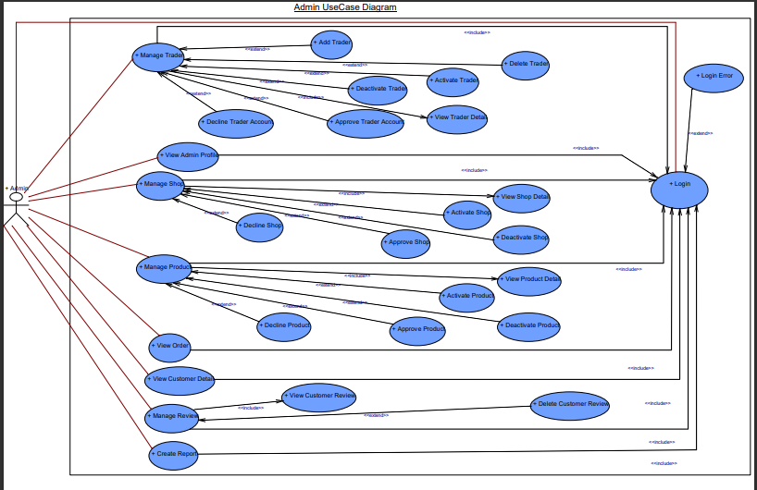

## 3.3 Requirement Catalogue

**FUNCTIONAL**

PRODUCT DETAIL

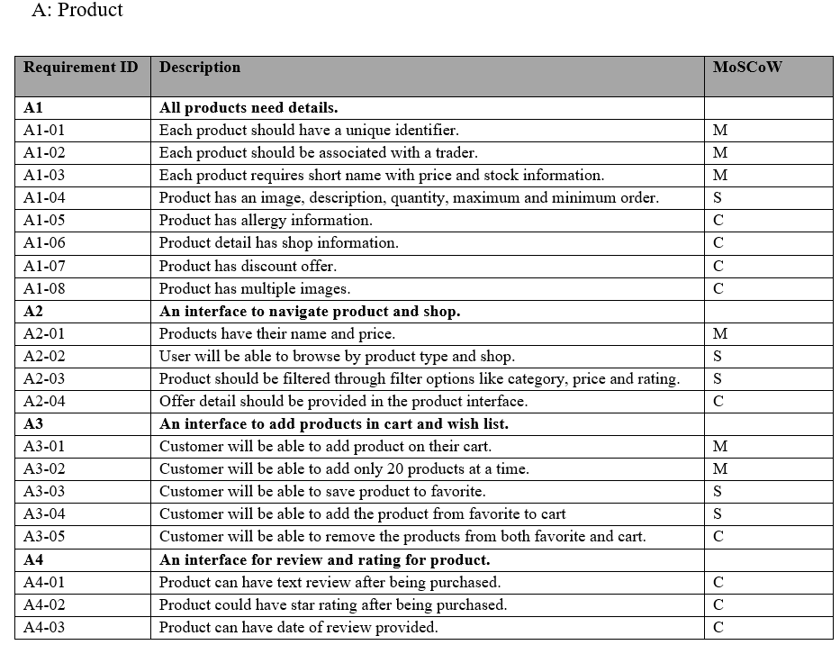

CUSTOMER DETAIL

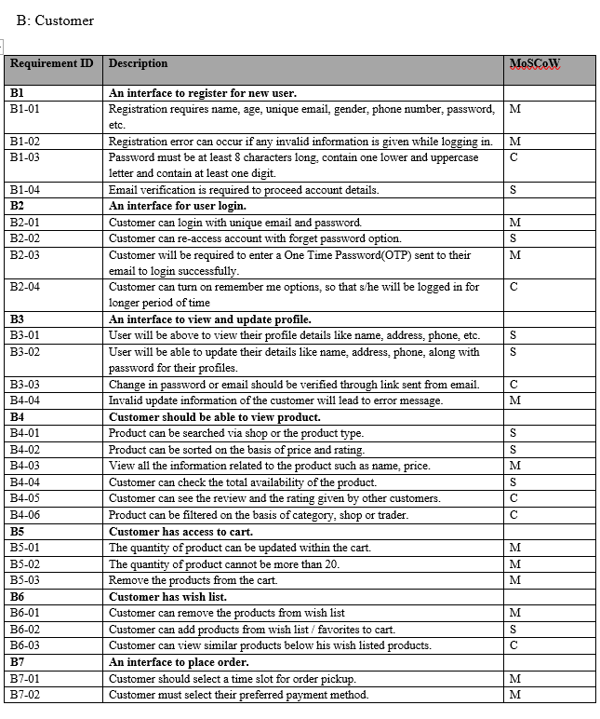

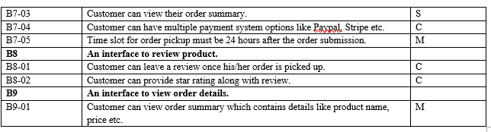

TRADER DETAIL

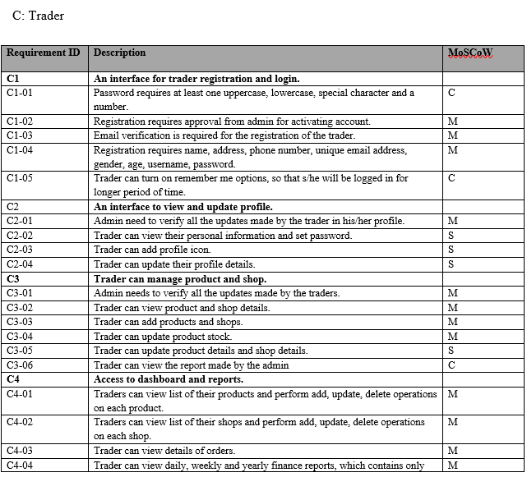

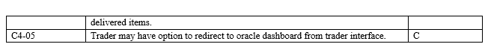

ADMIN DETAIL

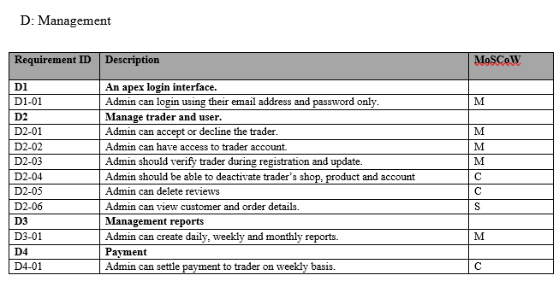

**NON FUNCTIONAL**

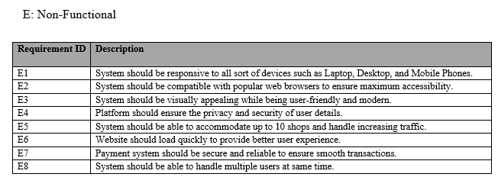

## 3.3 Logo

 

## 3.4 Wireframe

**LOGIN**

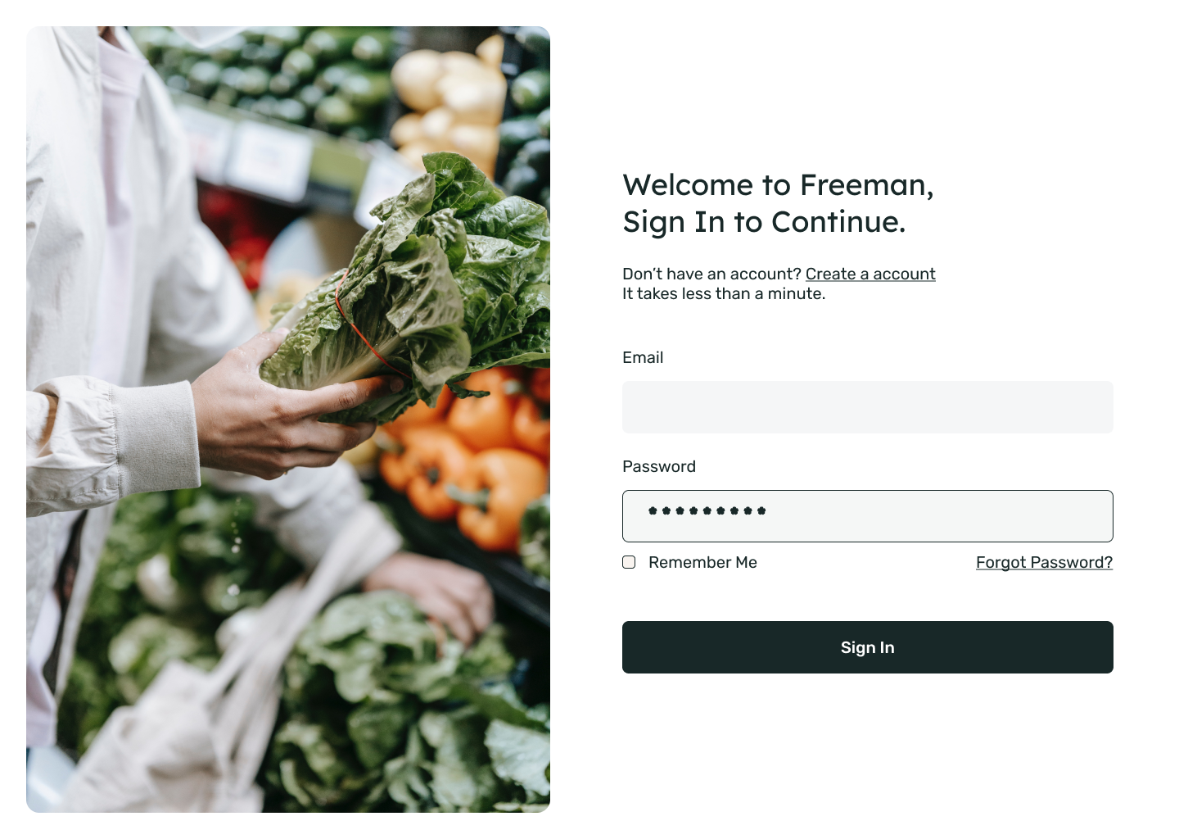

**CUSTOMER REGISTRATION**

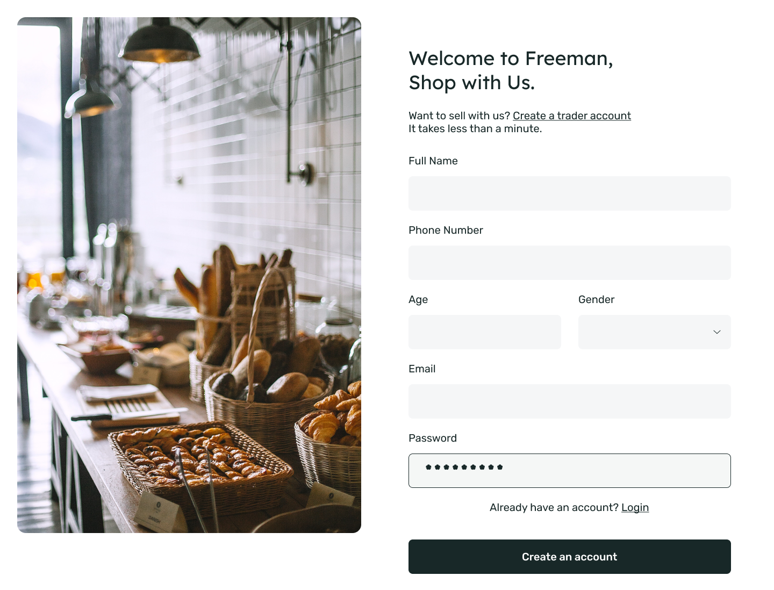

**HOME PAGE**

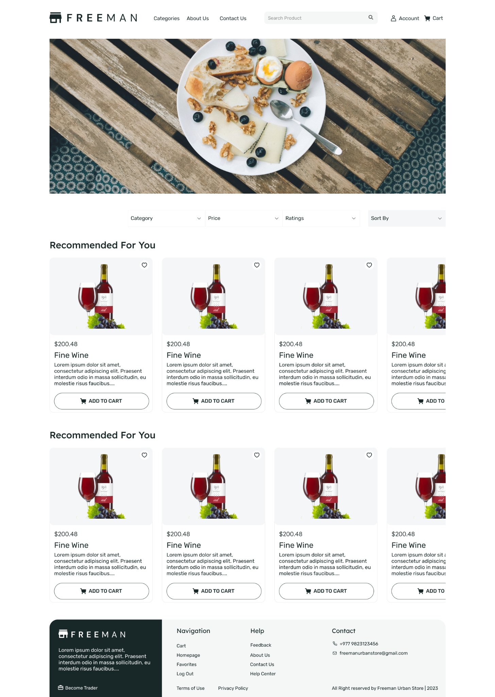

**TABLE ORDER**

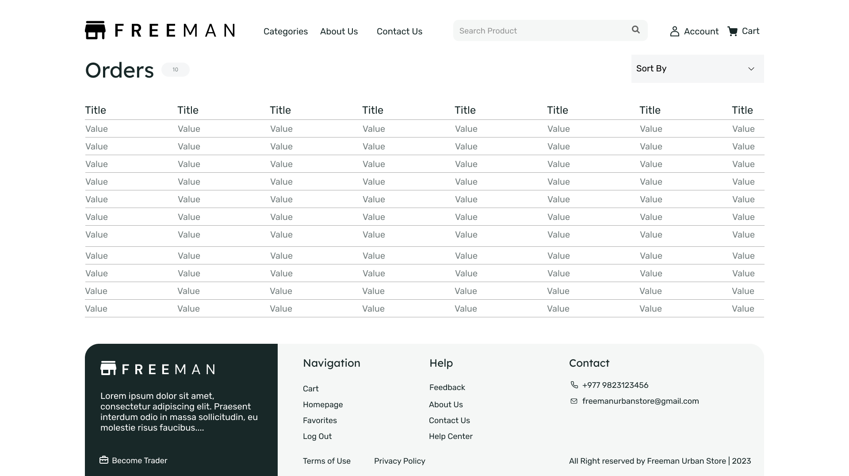

**CART**

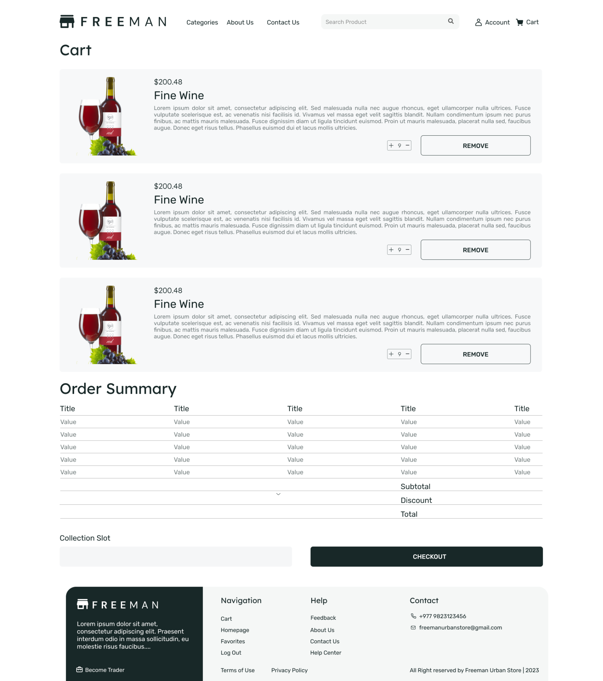

**INVOICE**

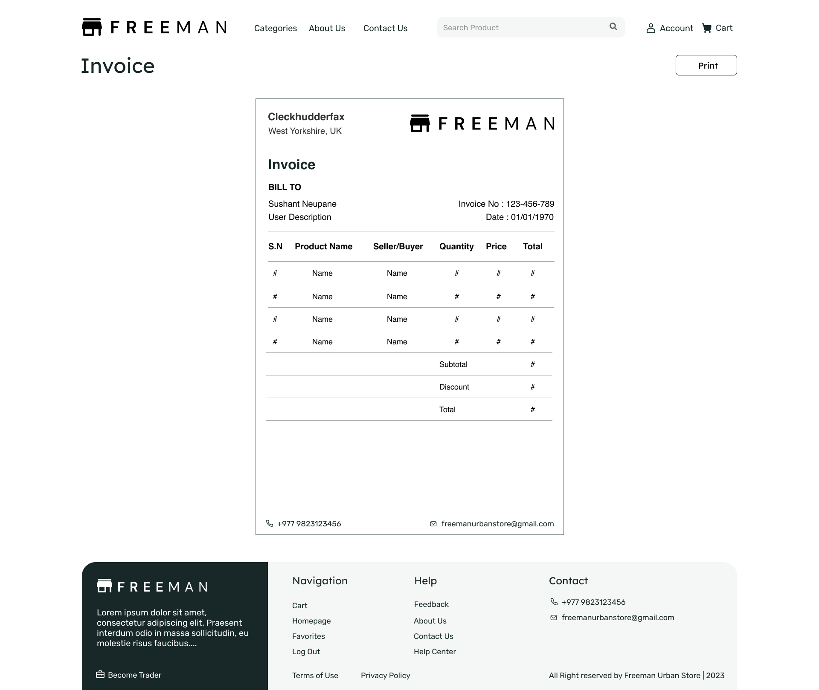

**PRODUCT DETAIL**

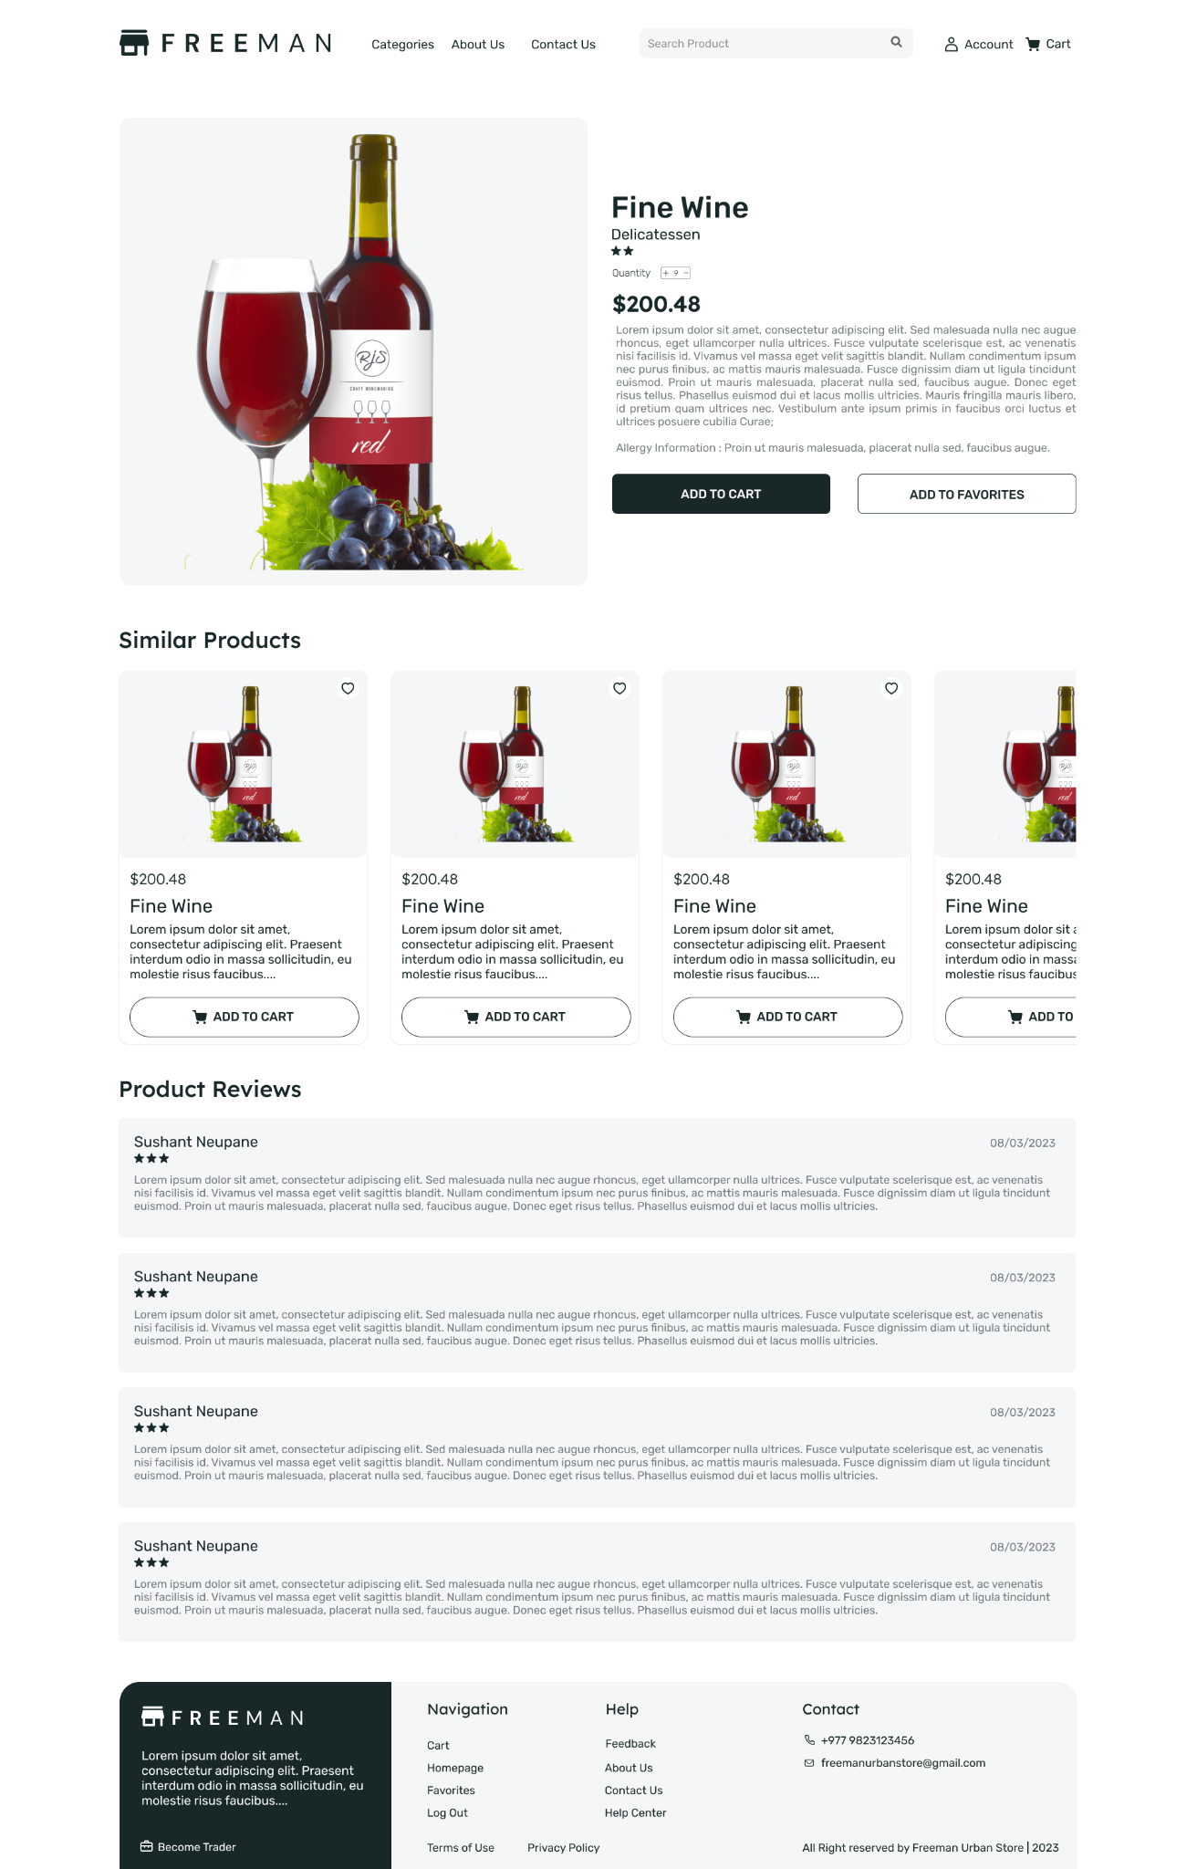

**ADMIN INTERFACE**

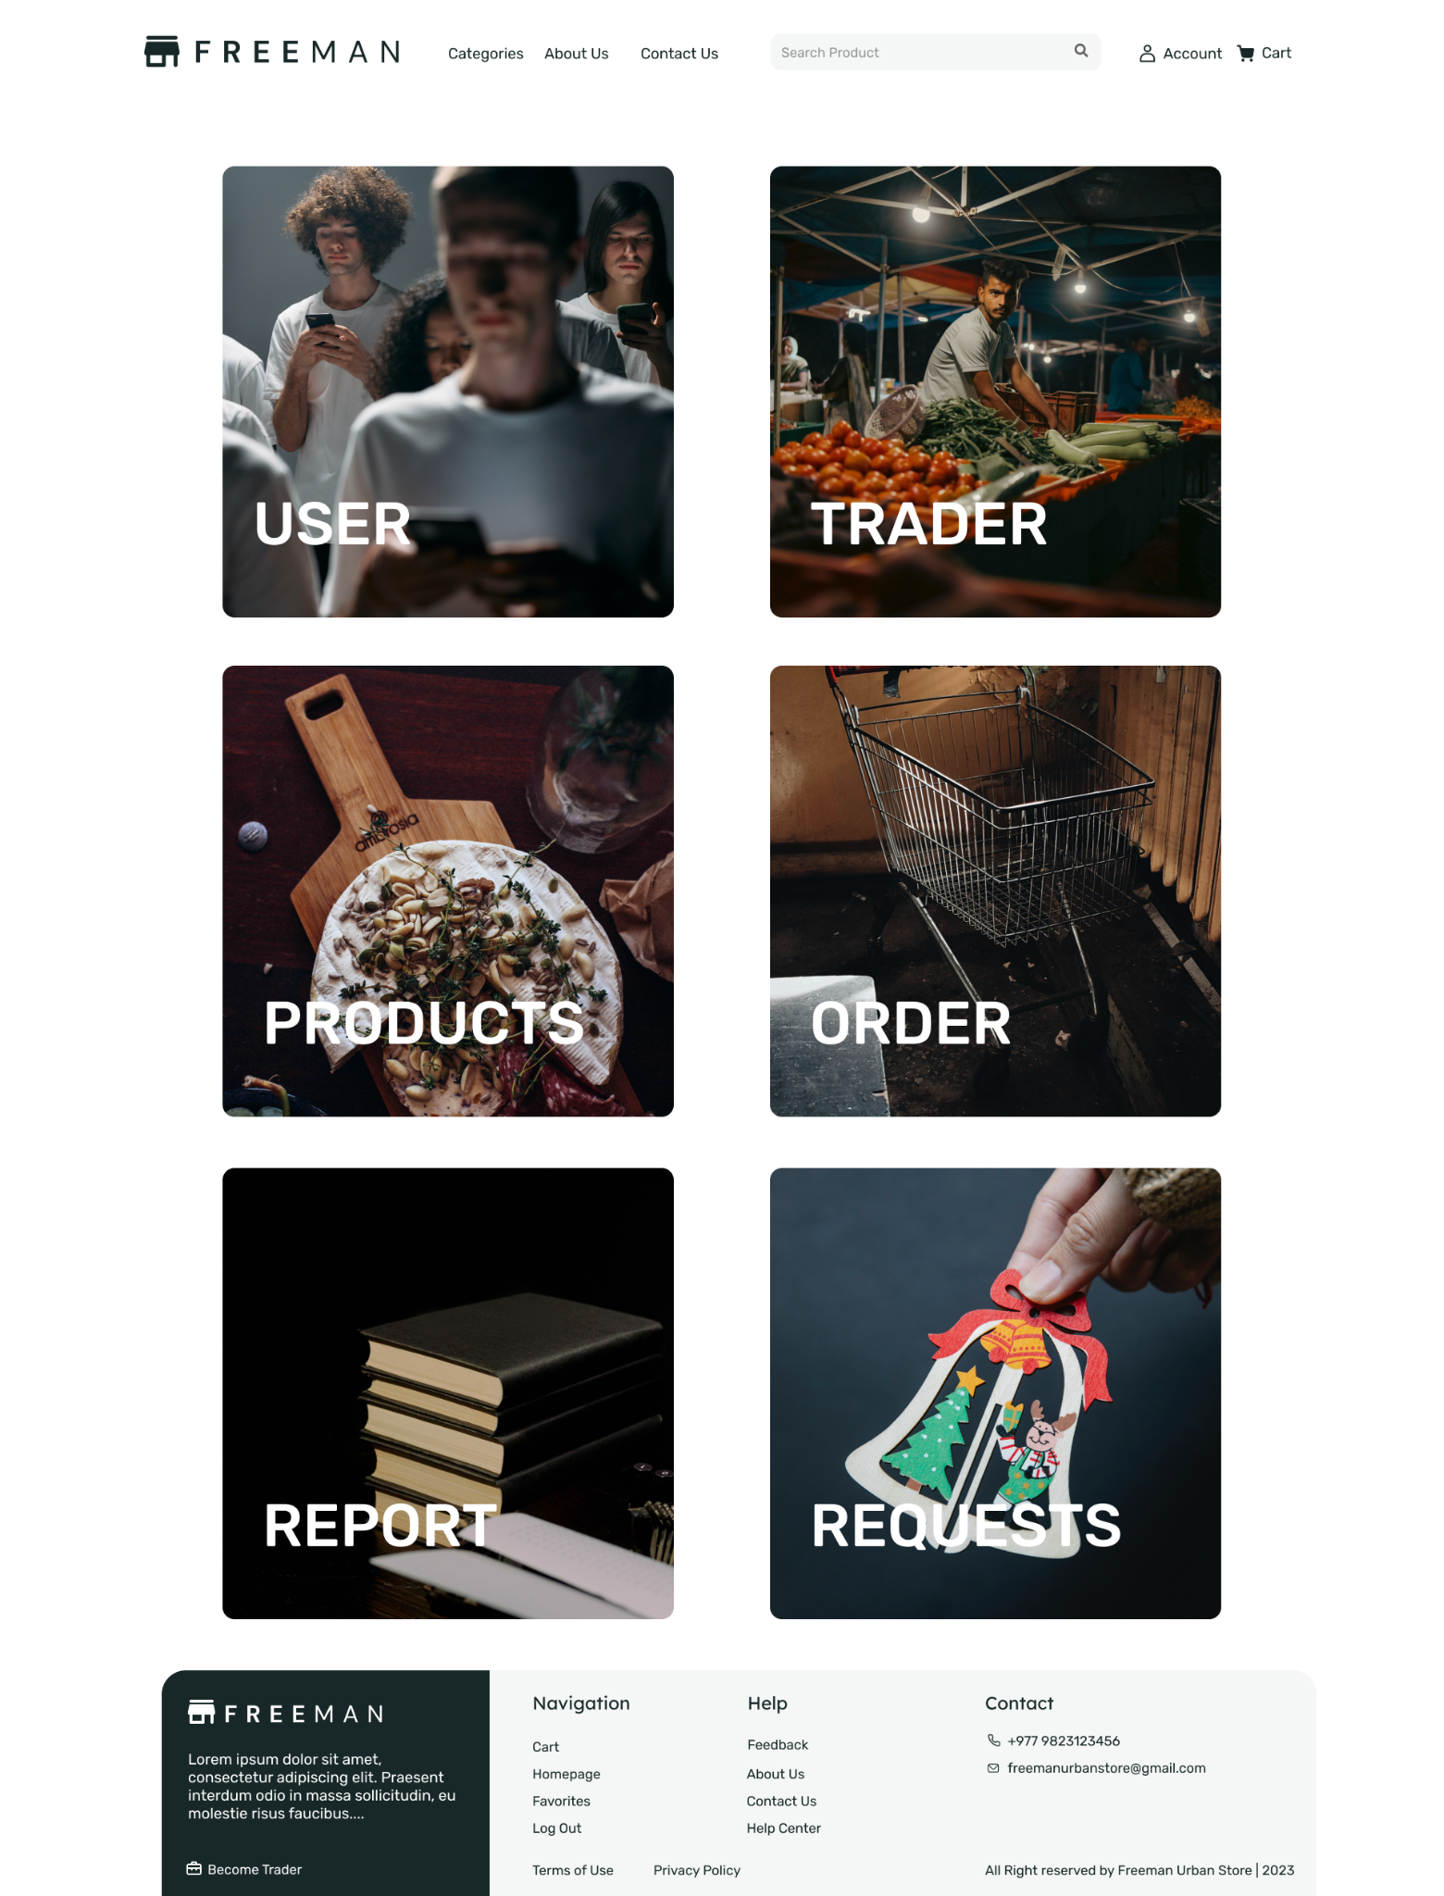

# **WEBSITE DEVELOPMENT**

**PROJECT SETUP**

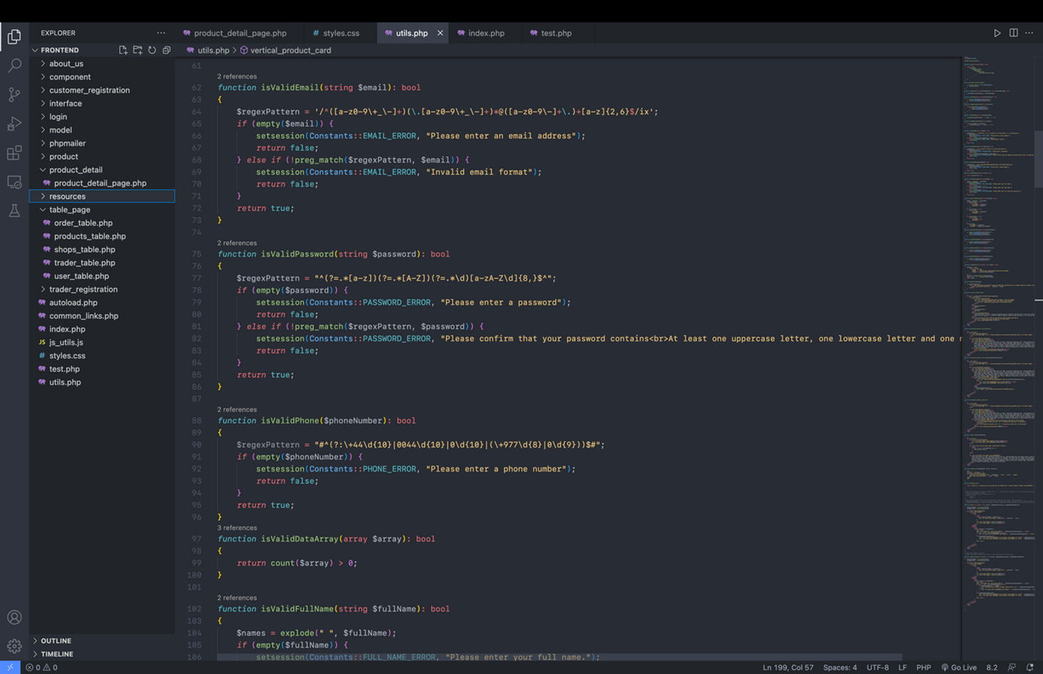

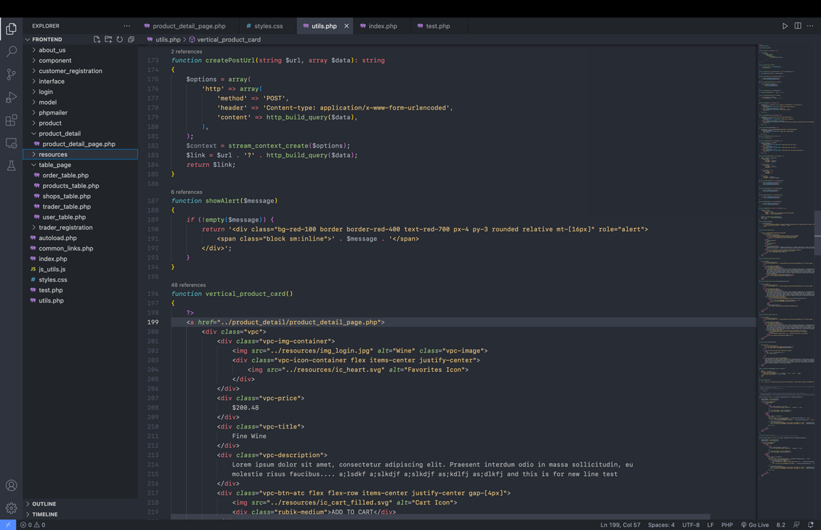

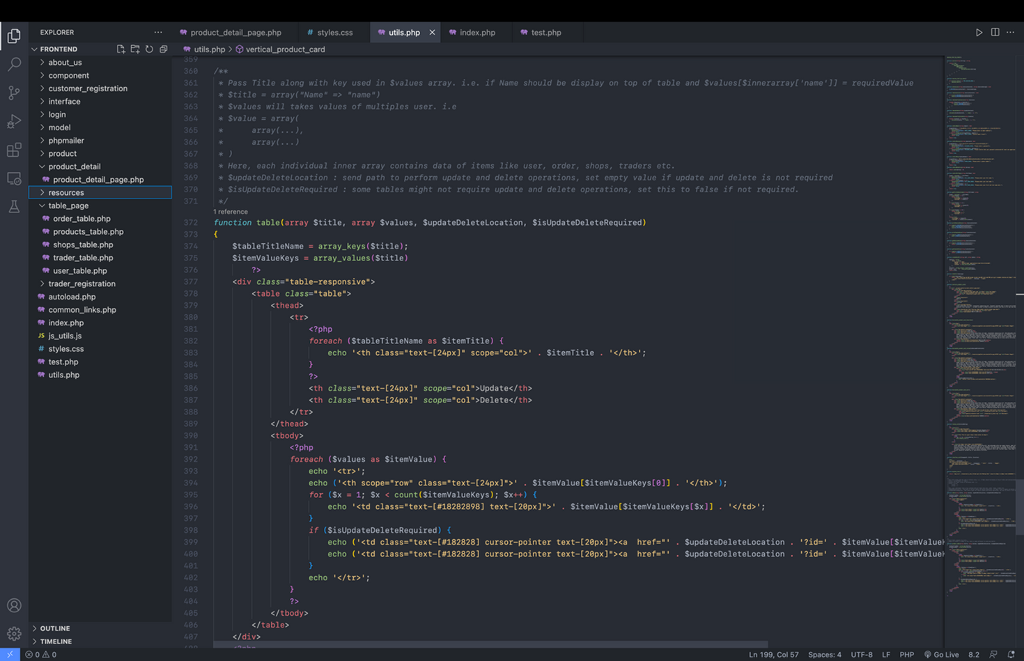

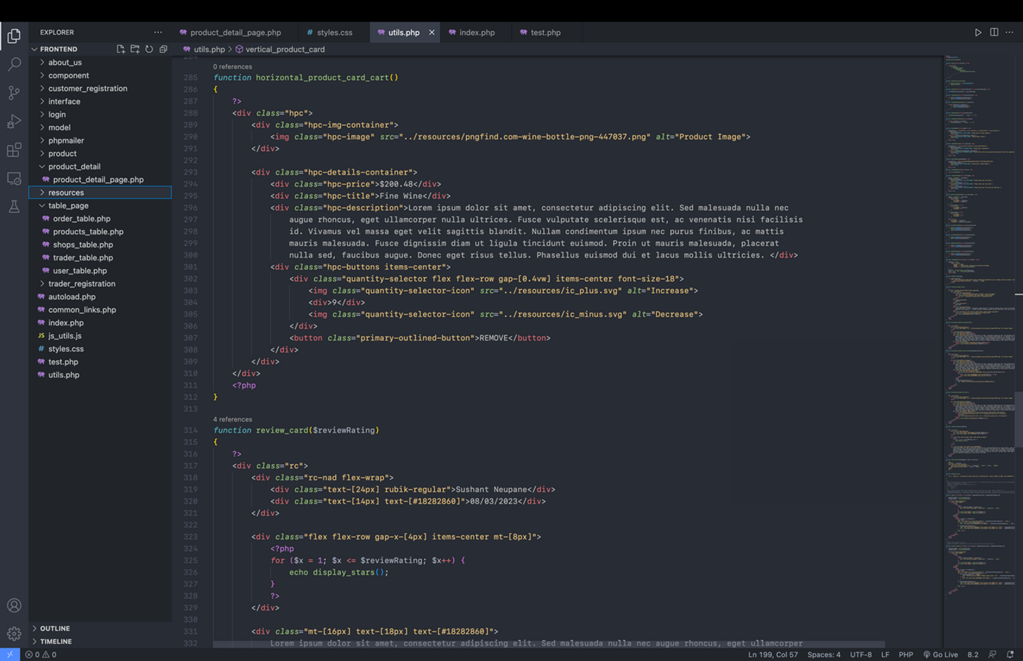

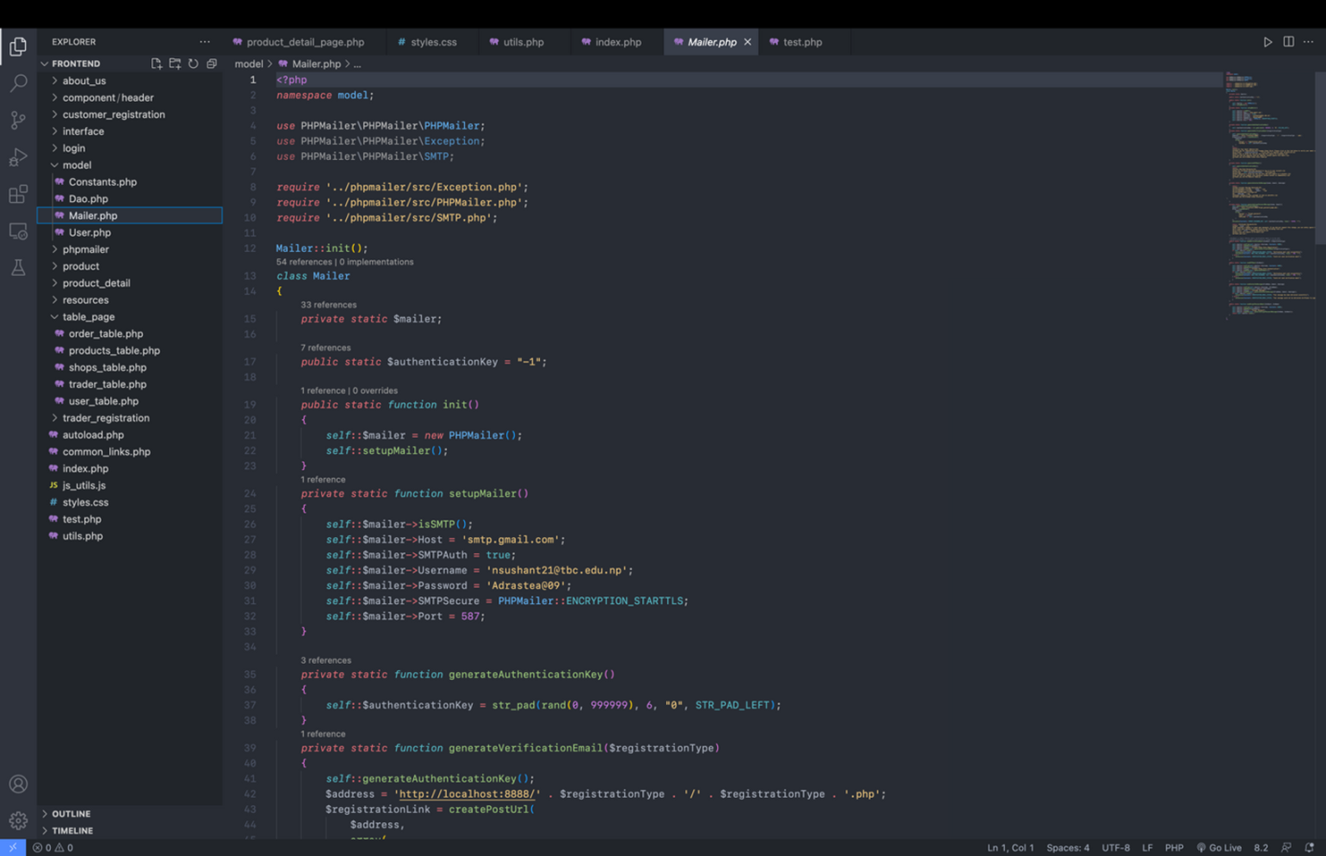

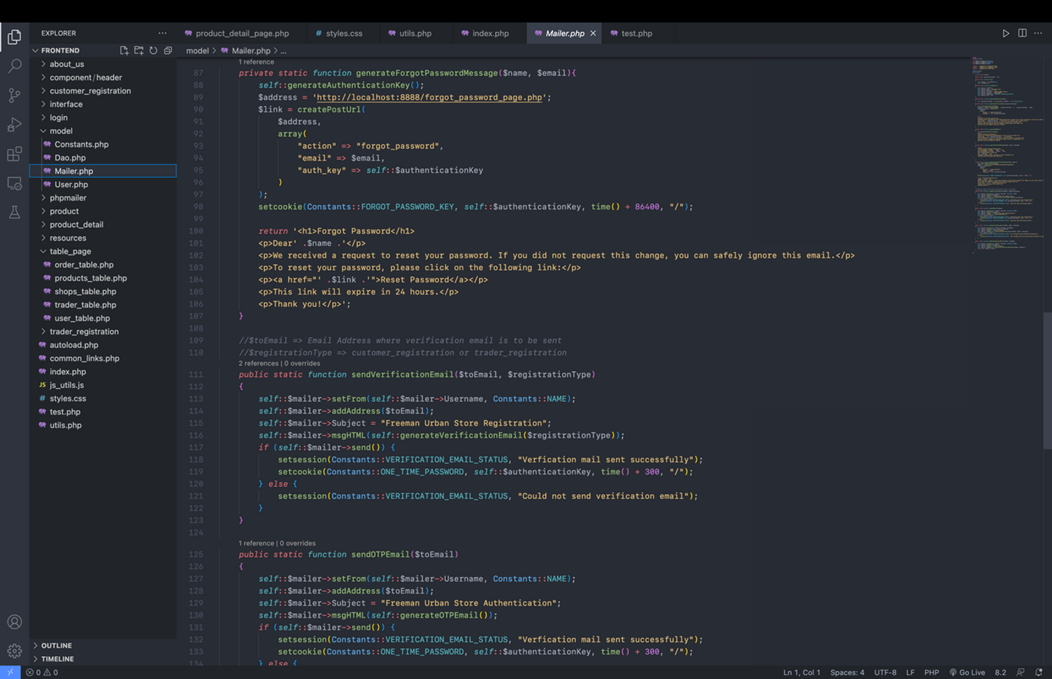

**LOGIN**

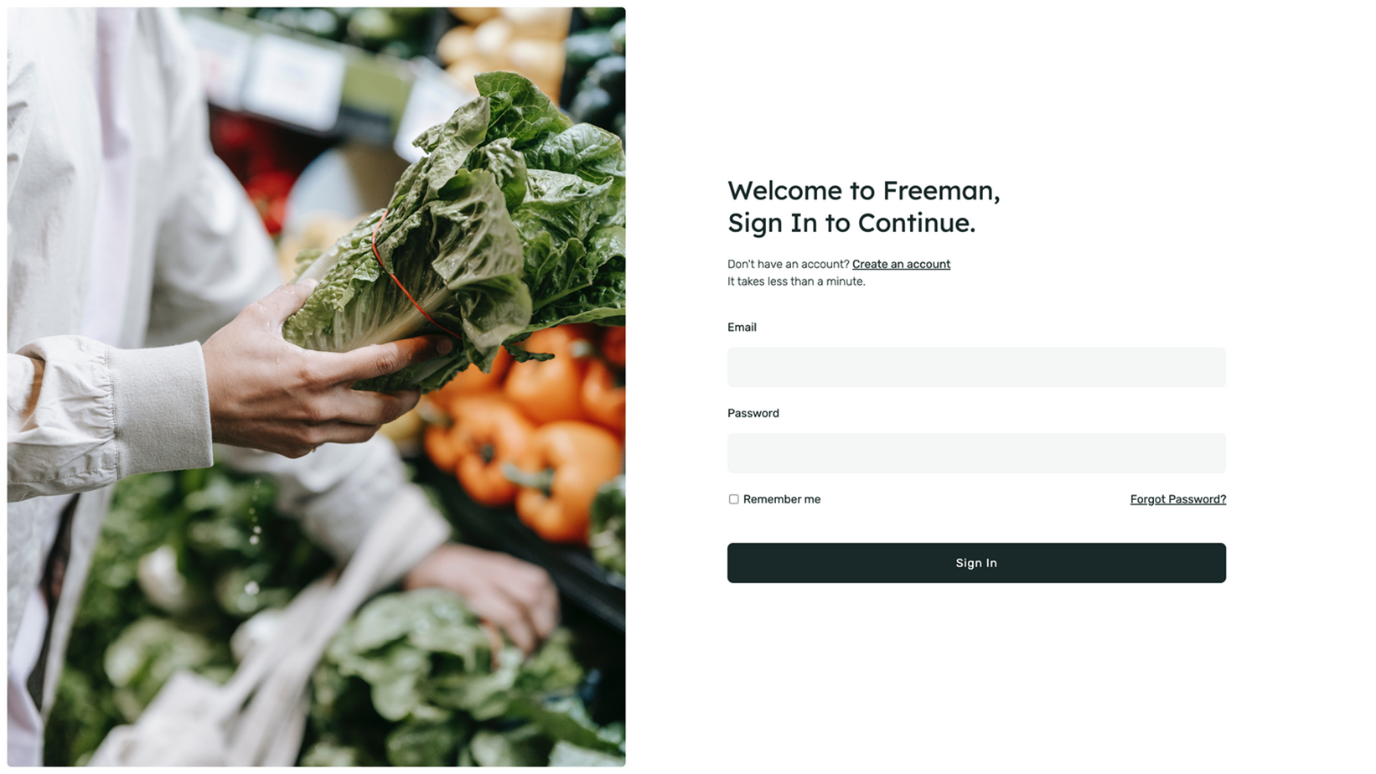

**Code:**

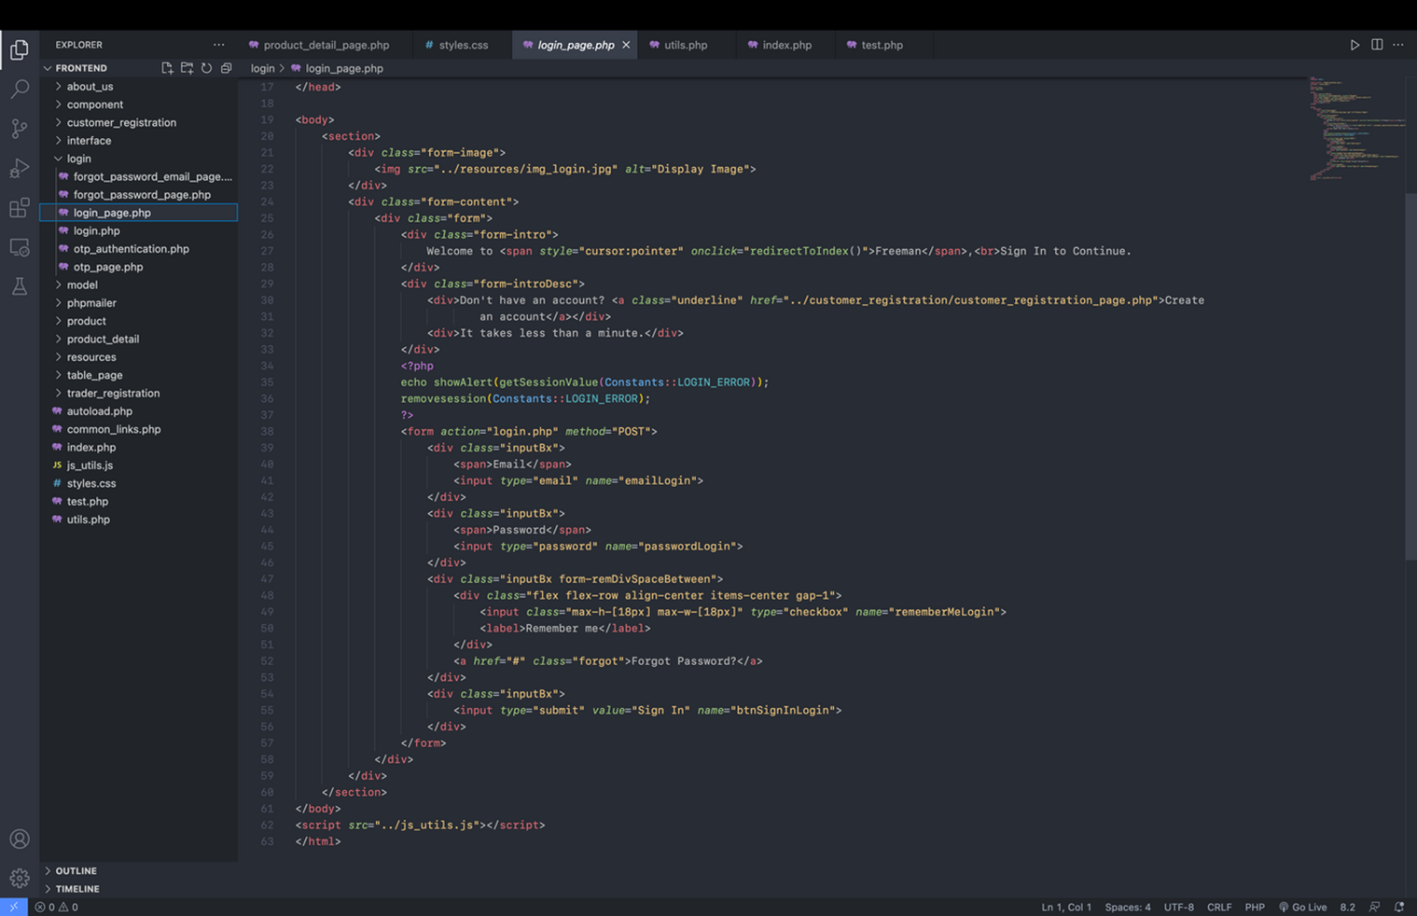

**REGISTER**

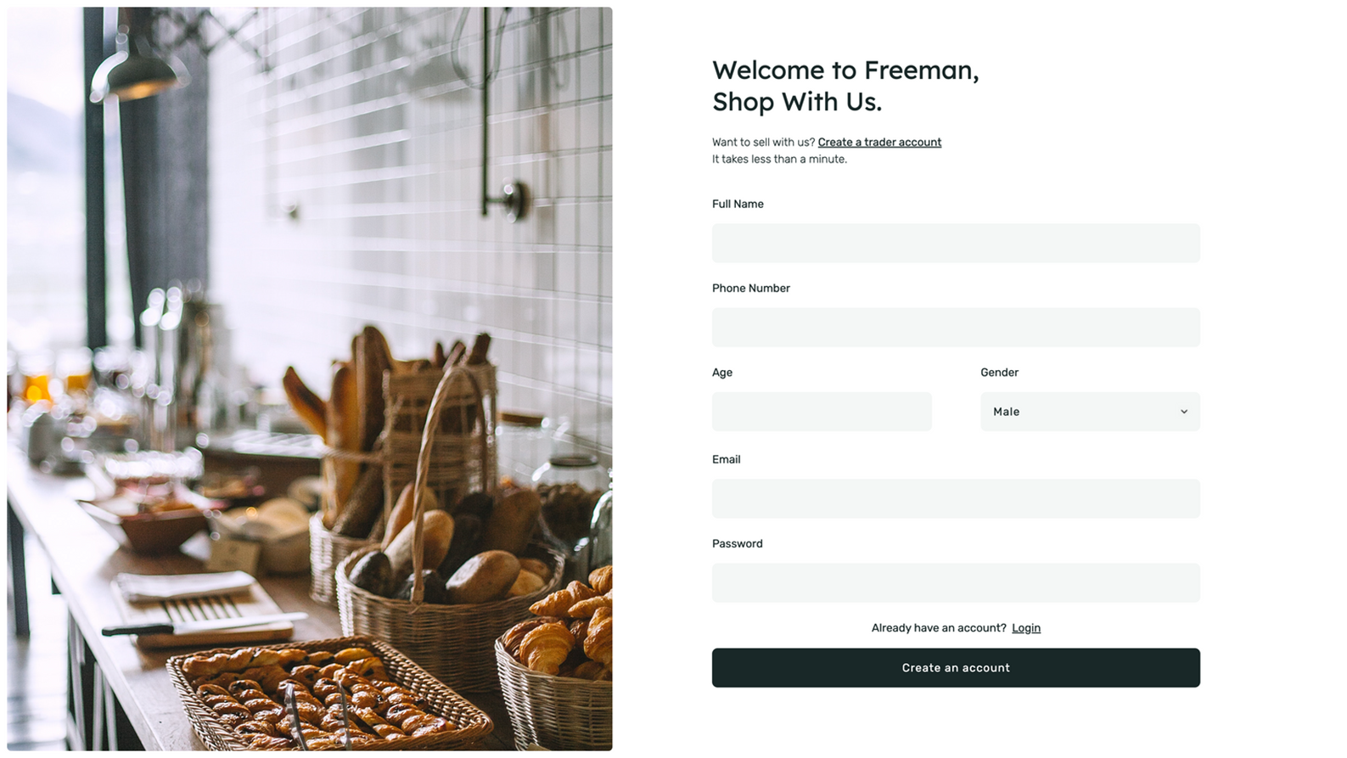

**Code:**

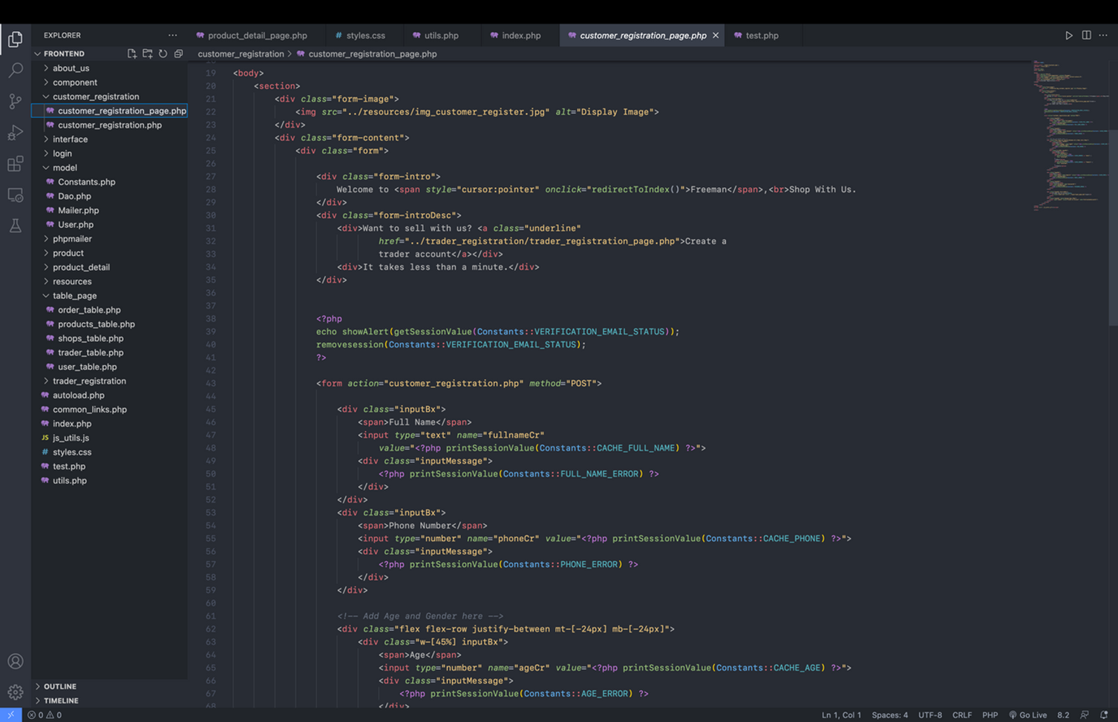

**HOME PAGE**

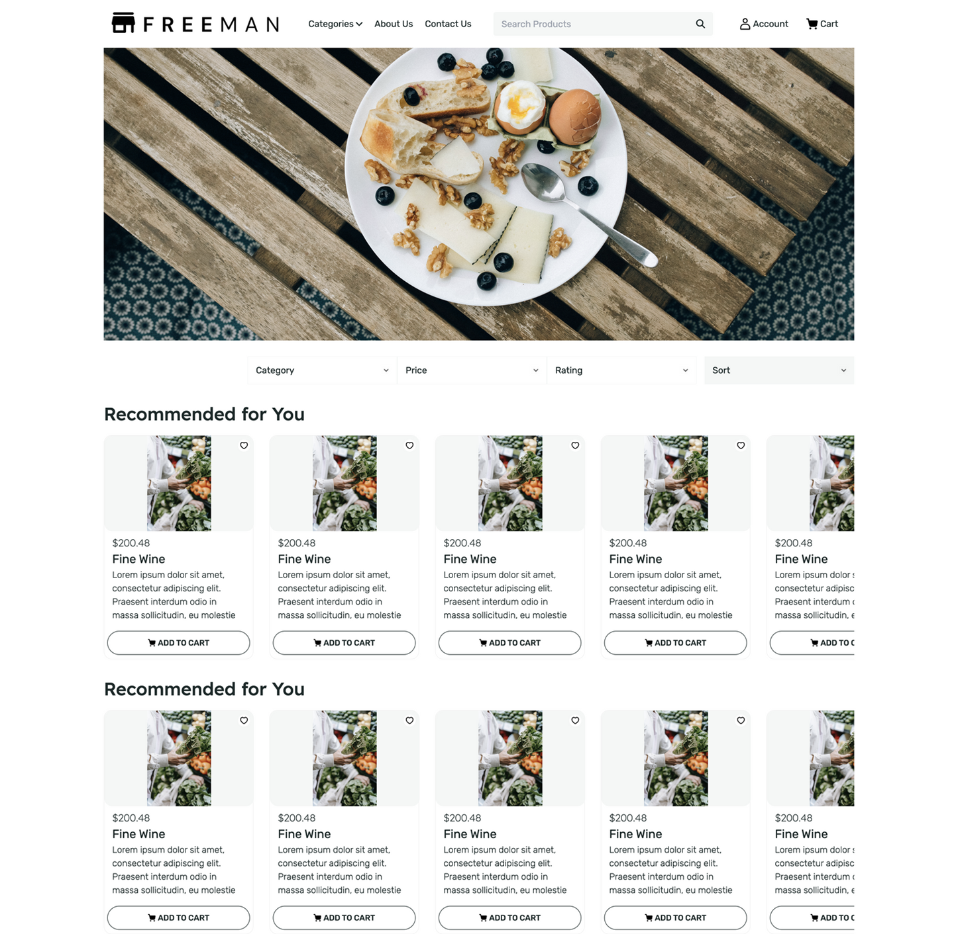

**Code:**

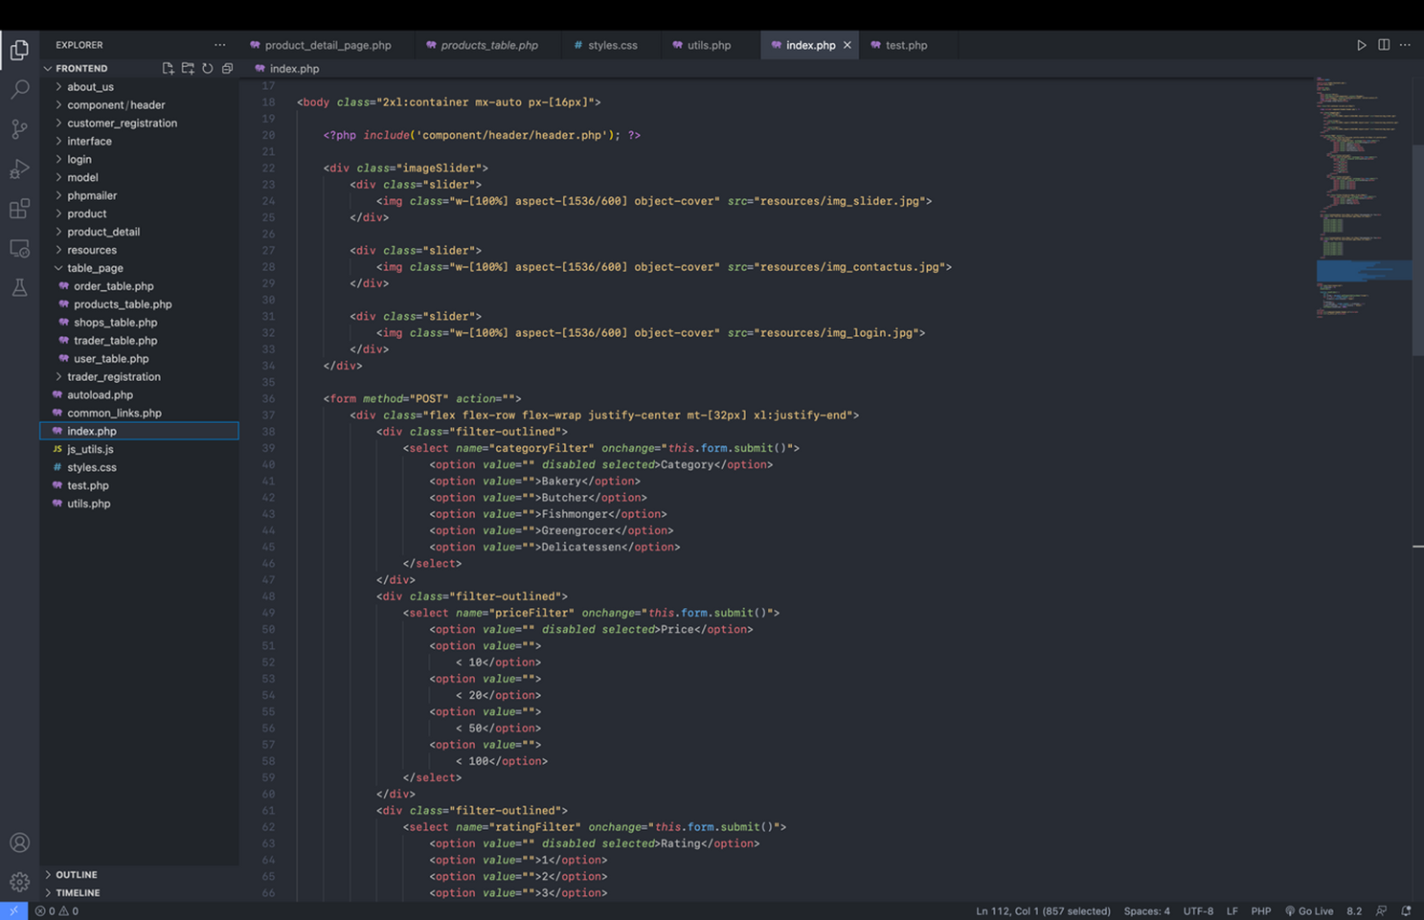

**PRODUCT PAGE**

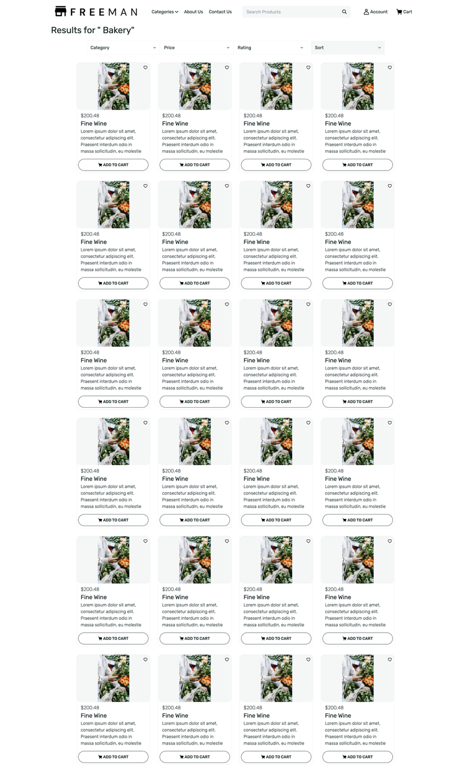

**Code:**

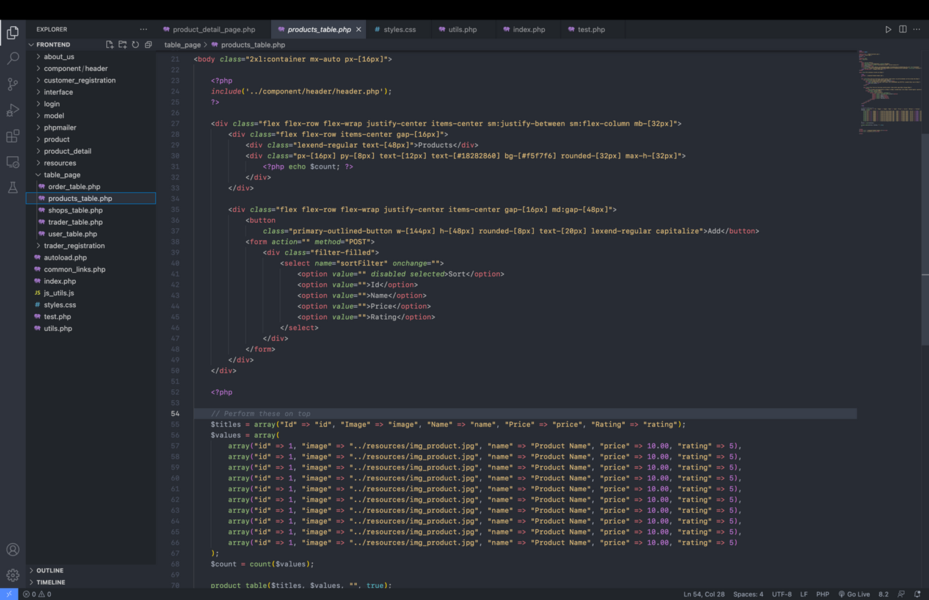

**PRODUCT DETAIL**

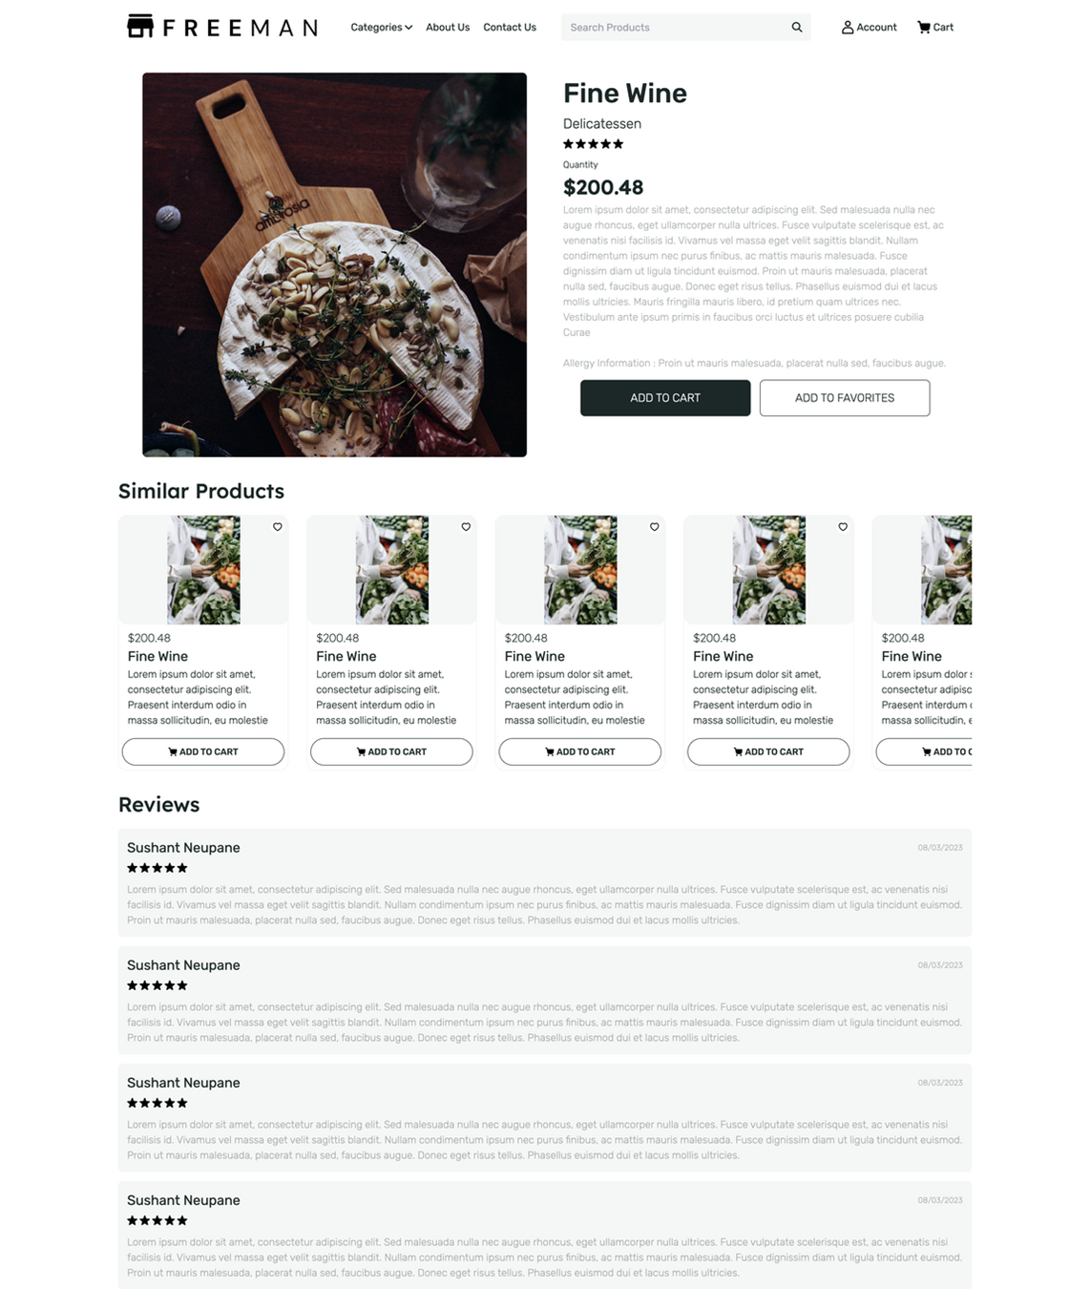

**Code:**

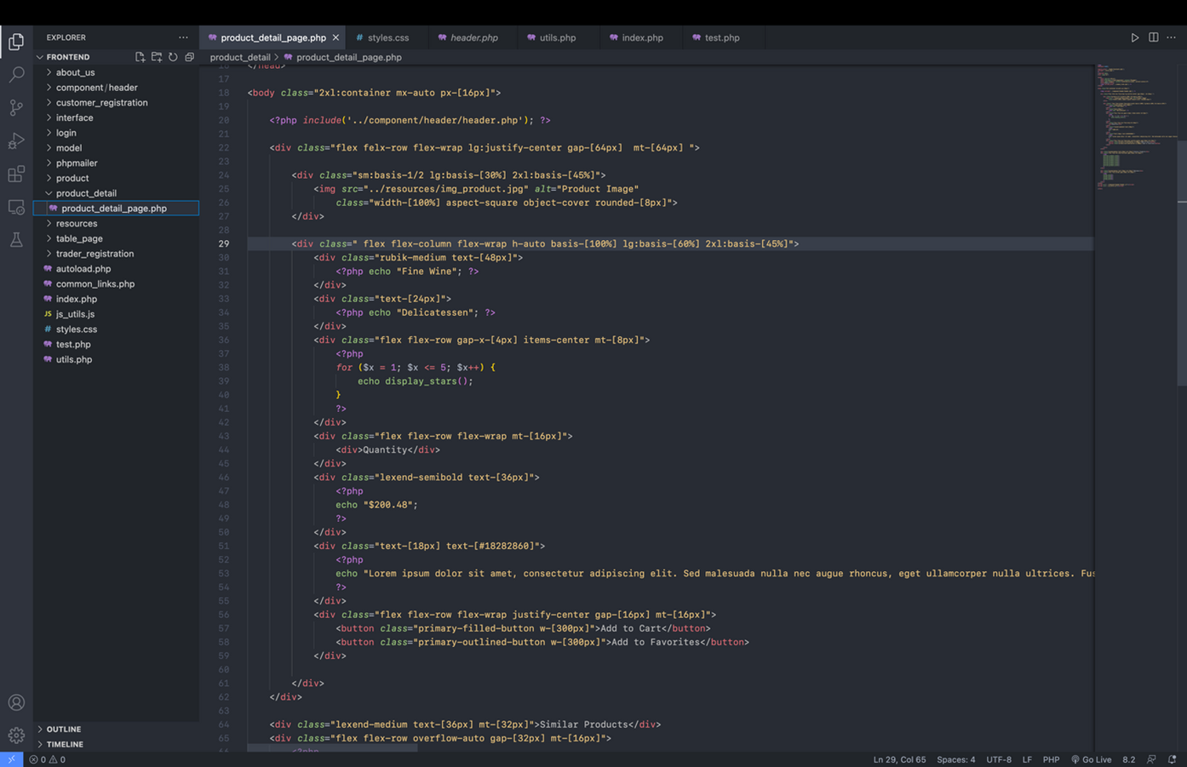

**ABOUT US**



**Code:**



**ADMIN INTERFACE**

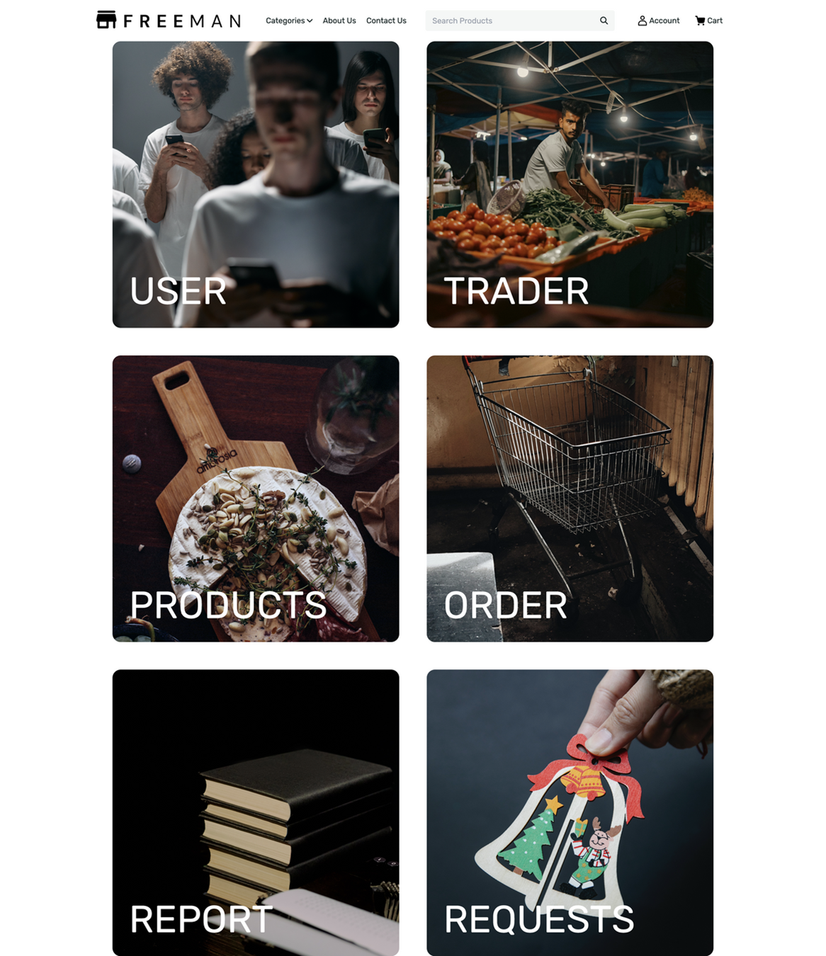

**Code:**

